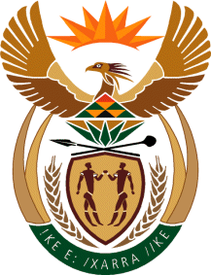

MINISTRY: COMMUNICATIONS
REPUBLIC OF SOUTH AFRICA
Private Bag X 745, Pretoria, 0001, Tel: +27 12 473 0164 Fax: +27 12 473 0585
Tshedimosetso House,1035 Francis Baard Street, Tshedimosetso House, Pretoria, 1000

NATIONAL ASSEMBLY
QUESTION FOR WRITTEN REPLY
QUESTION NUMBER: 3873 of 2015

Ms J Edwards (DA) to ask the Minister of Communications:
Whether actors who take part in the SA Broadcasting Corporation programmes which are broadcast on international SA Airways flights are paid royalties; if not, why not; if so, what are the relevant details?

REPLY: MINISTER OF COMMUNICATIONS
Not yet, these are recent deals and payment will be made after payment is made to the SABC and the 2015-16 financials are signed-off by the auditors.

MR NN MUNZHELELE
DIRECTOR GENERAL [ACTING]
DEPARTMENT OF COMMUNICATIONS
DATE:

MS AF MUTHAMBI (MP)
MINISTER OF COMMUNICATIONS
DATE:

