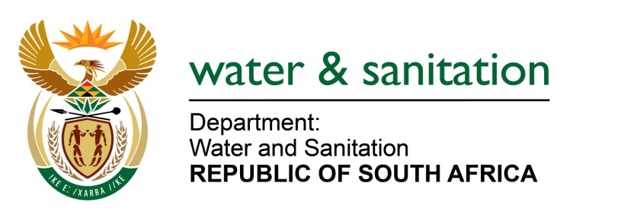

NATIONAL ASSEMBLY

FOR WRITTEN REPLY

QUESTION NO 3872

DATE OF PUBLICATION IN INTERNAL QUESTION PAPER: 28 OCTOBER 2022
(INTERNAL QUESTION PAPER NO. 42)

3872. Mr N G Myburgh (DA) to ask the Minister of Water and Sanitation
With reference to the Auditor-General’s 2021-22 report on his department, (a) what steps are being taken to design and implement a National Action Plan to address the growing scourge of water losses in various parts of the Republic and (b) by what date will the specified plan be ready for implementation?
NO4828E
---00O00---

MINISTER OF WATER AND SANITATION

- The Department acknowledges the deterioration of water and sanitation services at municipal level. The decline includes a growing trend on water losses and water use inefficiencies. In response to the decline, and along with the requirement by AGSA to develop an action plan, the Department is putting in place a Water Services Improvement Programme (WSIP) to strengthen its support and intervention at municipal level based on actual data or most available data. The aim of the programme is for the Department to ensure that support and intervention at municipal level is proactive, consistent, and systematic as opposed to current ad-hoc approach. In line with the WSIP, the Department has further established the Water Partnership Office (WPO) within the Development Bank of Southern Africa (DBSA). The WPO has developed five standardized National Programmes for private sector participation in municipal water and sanitation services, to make it easier, quicker, and cheaper for municipalities to enter into partnerships, without having to ‘reinvent the wheel’ for each partnership. One of the five National Programmes within the WPO is Non- Revenue Water (NRW) programme aimed at implementing the Water Conservation and Water Demand Management and cost recovery programme focusing on reducing losses, reducing over consumption, and improving cost recovery

- A part of the programme is being implemented; the intention is to roll it out Nationally in the next Financial Year (2023/24 FY)

---00O00---

