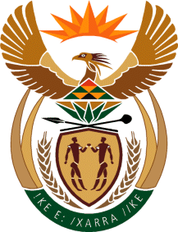

MINISTRY: COMMUNICATIONS
REPUBLIC OF SOUTH AFRICA
Private Bag X 745, Pretoria, 0001, Tel: +27 12 473 0164 Fax: +27 12 473 0585
Tshedimosetso House,1035 Francis Baard Street, Tshedimosetso House, Pretoria, 1000

NATIONAL ASSEMBLY
QUESTION FOR WRITTEN REPLY
QUESTION NUMBER: 3870 of 2015

Mr P van Dalen (DA) to ask the Minister of Communications:
(1) In respect of how many programmes has the SA Broadcasting Corporation (SABC) sold the rights to air to kykNET; ? (2) whether the affected actors have been receiving royalties from the specified SABC transaction; if not, why not; if so, when did they start receiving royalties?

REPLY: MINISTER OF COMMUNICATIONS
(1) Sixty-nine titles
(2) No. In most instances due to the age of the programmes and the commissioning regimes under which they were made no contractual provision was made for royalties to be paid to actors and as such no payments have been made.

MR NN MUNZHELELE
DIRECTOR GENERAL [ACTING]
DEPARTMENT OF COMMUNICATIONS
DATE:

MS AF MUTHAMBI (MP)
MINISTER OF COMMUNICATIONS
DATE:

