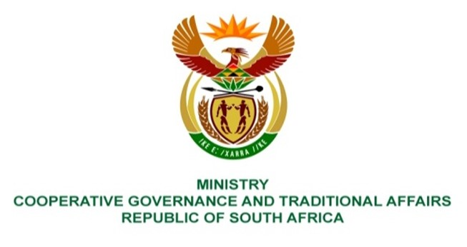

NATIONAL ASSEMBLY
QUESTION FOR WRITTEN REPLY

QUESTION NUMBER 387
DATE OF PUBLICATION: 18 FEBRUARY 2022

QUESTION:

387: Ms S A Buthelezi (IFP) to ask the Minister of Cooperative Governance and Traditional Affairs:
What is her department’s plan to address the issue of nonviable municipalities particularly to ensure that the situation is improved to bring about economic growth and job creation? NW401E

REPLY:
The Department has over the years implemented initiatives to support Local Economic Development at a municipal level. In 2018 the Department released the National Framework on Local Economic Development which sought to encourage all actors and role players to recognise the critical importance of Science, Technology and Innovation (STI) as a catalyst to promote inclusive, local economic growth and development.

Guided by framework, the Department has championed the establishsment of Business Development Forums (BDFs) which seeks to address the public sector – private sector divide as it relates to the planning and implementation of local economic development programmes. The BDFs have been implemented in municipalities such as West Coast; Sara Baartmaan, Ehlanzeni and Umgungundlovu District Municipalities.

The Department has also been involved in various Business Adopt a Municipality (BAaM) / Partnership projects with the business sector and State Owned Companies to support municipalities in addressing the challenges they face in complying to their legislative mandate.Partnerships established under the BAaM programme are different to other relationships between local government and the private sector in that they offer an opportunity for the private sector to share its experiences, skills and resources to directly support service delivery in a structured fashion at local level.

The Department in collaboration with the DTI and SALGA produced guidelines for reducing red tape in municipalities. The evidence study pointed out that municipal managers are usually focused on improving municipal financial audit results, and not on reducing Red Tape. The guidelines call upon municipal managers to prioritise both the improvement of audit ratings and the reduction of Red Tape. Among others, the guidelines recommend the initiation of Red Tape Reduction programmes by municipalities in conjunction with local business entities.
Lastly, the Department is coordinating the implementation of the District Develomplent Model (DDM) which is anchored on the development and implementation of district and metro one plans. One of the critical focus areas of the one plan is economic positioning - which is about that ensuring that districts and metros throughout the country understand their competitive and comparative advangateges and utilise them to grow their economies. The district and metro one plans are also meant to facilitate the reimagining district and metro spaces to promote inclusive growth and development. Importantly, one plans contain catalytic projects that will be implemented over a medium to long term to support economic recovery and growth in the districts and metros.
Through the DDM approach, the department is championing a programme focusing on the alignment of the Cooperatives based community economic development model to the District Development Model to address service delivery challenges in Municipalities. This programme seeks to address amongst others the following challenges - high rate of unemployment and poverty; minimal community participation in their development; lack of focus on repairs and maintenance to reduce government expenditure and carbon emission; and over dependency of poor families on government handouts and services. The programme is being piloted in Kwa-Zulu Natal Province focusing on Land fill, routine road maintenance, and potholes patching targeting Community Works Programme Participants.

