FOR WRITTEN REPLY

NATIONAL ASSEMBLY
36/1/4/1(201900049)

QUESTION 387

DATE OF PUBLICATION IN INTERNAL QUESTION PAPER: 22 FEBRUARY 2019 (INTERNAL QUESTION PAPER NO 3-2019)

387. Mr D J Stubbe (DA) to ask the Minister of Police:

What number of (a) children and (b) adults were reported as having been kidnapped in the (i) 2015-16, (ii) 2016-17 and (iii) 2017-18 financial years?
NW411E
REPLY:

(a)(b)(i)(ii)(iii)

 | Year | (a) Children | (b) Adults
(i) | 2015/2016 | 692 | 2 539
(ii) | 2016/2017 | 596 | 2 399
(iii) | 2017/2018 | 626 | 2 622

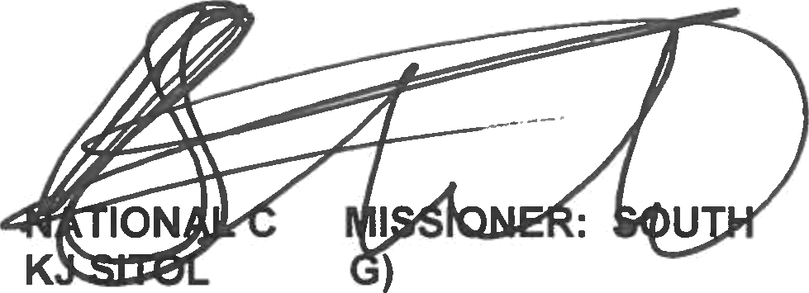
Reply to question 387 recommended/

OM E (SOE
Date: 2011 -01- c s

GENERAL AFRICAN POLICE SERVICE

Reply to question 387 approved/not approved

MINISTER OF POLICE BH CELE, MP

Date:

