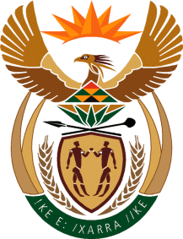

MINISTRY OF TOURISM
REPUBLIC OF SOUTH AFRICA

Private Bag X424, Pretoria, 0001, South Africa. Tel. (+27 12) 444 6780, Fax (+27 12) 444 7027
Private Bag X9154, Cape Town, 8000, South Africa. Tel. (+27 21) 469 5800, Fax: (+27 21) 465 3216

NATIONAL ASSEMBLY:

QUESTION FOR WRITTEN REPLY:
Question Number: 386
Date of Publication: 19 February 2021
NA IQP Number: 2
Date of reply: 04 March 2021

Mr K P Sithole (IFP) to ask the Minister of Tourism:
Whether, with reference to the recent statement of the President, Mr M C Ramaphosa, that the Tourism Recovery Plan entails three strategic themes, namely reigniting demand, rejuvenating supply and strengthening enabling capability, she will break the strategies down into practical examples of how her department will ensure the success of the plan; if not, what is the position in this regard; if so, what are the (a) full relevant details and (b) timelines attached to the plan? NW392E

REPLY:

The Tourism Sector Recovery Plan’s interventions shall be contained in the plan which will be publicly available upon completion of Cabinet approval processes in this regard. The plan will also be integrated into the Annual Performance Plans of both the Department of Tourism and South African Tourism starting 2021/22 financial year to ensure implementation thereof. Furthermore, the plan also takes into account a whole of government approach in its implementation.

- – ( b) Not applicable

