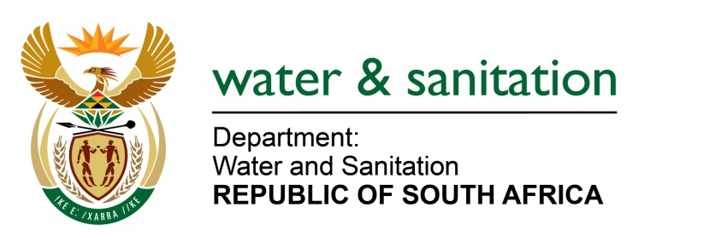

NATIONAL ASSEMBLY

FOR ORAL REPLY

QUESTION NO 3858

DATE OF PUBLICATION IN INTERNAL QUESTION PAPER: 28 OCTOBER 2022
(INTERNAL QUESTION PAPER NO. 42)

3858. Ms S A Buthelezi (IFP) to ask the Minister of Water and Sanitation: [676][

(1) What are the relevant details of how his department intends to balance the repairing and maintenance of water supply infrastructure with the plans of his department to expand access to water.

(2) considering the magnitude of the irregular expenditure in his department, what are the relevant details of how his department will implement the initiatives to balance the two aspects without the implementation contributing to further wasteful expenditure by his department?

NO4749E
---00O00---
MINISTER OF WATER AND SANITATION

- The Department of Water and Sanitation (the Department) has a maintenance plan in place for government water schemes which includes all activities to ensure adherence to routine, planned and unplanned maintenance requirements. The maintenance plan is informed by the Asset Management Plan of the Department. Furthermore, the Department has entered into agreements with some Water User Associations (WUAs) and Irrigation Boards (IB) to operate and maintain water schemes to ensure increased water security or sustainable bulk raw water supply for economic and social water users.

- The Department has, through a competitive bidding process, appointed sixteen (16) mechanical and electrical engineering maintenance contractors for a period of three (3) years, to augment existing capacity.

