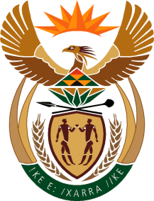

MINISTRY OF TOURISM
REPUBLIC OF SOUTH AFRICA

Private Bag X424, Pretoria, 0001, South Africa. Tel. (+27 12) 444 6780, Fax (+27 12) 444 7027
Private Bag X9154, Cape Town, 8000, South Africa. Tel. (+27 21) 469 5800, Fax: (+27 21) 465 3216

NATIONAL ASSEMBLY:

QUESTION FOR WRITTEN REPLY:
Question Number: 3858
Date of Publication: 6 December 2018
NA IQP Number: 45
Date of reply: 19 December 2018

Mr S Mokgalapa (DA) to ask the Minister of Tourism:
(1) Whether (a) his department and/or (b) any entity reporting to him contracted the services of Bosasa now known as African Global Operations in each of the past 10 financial years; if so, what (i) number of contracts were signed, (ii) was the date on which each contract was signed, (iii) was the duration of each contract, (iv) services did the company render and (v) was the monetary value of each contract in each case;
(2) whether any irregular expenditure relating to the contracts was recorded and/or condoned in each case; if so, what are the relevant details? NW4436E

Reply:
- (a) Department
Contracted the service of Bosasa (African Global Operations) since 2008?
The Department of Tourism since its existence (01 April 2010) has never contracted the services of Bosasa (African Global Operations).
(i) – (v) Not applicable.
- (a) Was there any irregular spending related to the contracts or condoned in each case? – Not applicable

(1)(b) South African Tourism
South African Tourism has not contracted Bosasa (African Global Operations) for any services for the period in question nor during any period earlier.
(i) – (v) Not applicable

(2)(b) Was there any irregular spending related to the contracts or condoned in each case?
Not applicable

