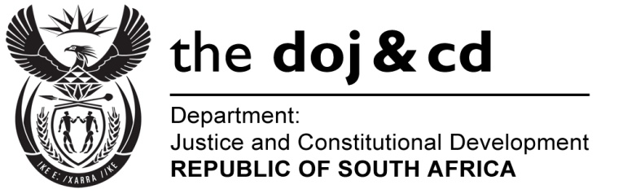

NATIONAL ASSEMBLY
QUESTION FOR WRITTEN REPLY
PARLIAMENTARY QUESTION NO.: 3851
DATE OF QUESTION: 30 OCTOBER 2015
DATE OF REPLY: 13 NOVEMBER 2015

3851. Mr A F Mahlalela (ANC) to ask the Minister of Justice and Correctional Services:

Whether he intends to implement the recommendations of the Truth and Reconciliation Commission’s amnesty committee dated 27 November 2000 in relation to the application of a certain person (name furnished); if not, why not; if so, what are the relevant details? NW4661E

Person concerned: Mr Voice Morris Sambo.

REPLY:

I wish to inform the Honourable Member that Mr Voice Morris Sambo was refused amnesty by the Truth and Reconciliation Commission (TRC) because he failed to make full disclosure.

The TRC nevertheless recommended that despite the refusal of Mr Sambo’s application, the Committee is of the view that in the light of the continued and considerable harassment that the applicant was subjected to and particularly in the light of the extremely harsh sentence that the applicant received, that this is an appropriate case for executive intervention. Accordingly, the TRC recommended that the Ministries of Justice and Correctional Services investigate the matter with a view to affording the applicant an appropriate reduction in sentence.

Sentences are, however, imposed by the courts. I as Minister of Justice of and Correctional Services, have no power to reduce a sentence or to pardon those who have been found guilty and sentenced by the courts.

I would recommend however, that Mr Sambo consider the following two (2) options:
Firstly, applying for a Presidential pardon to the President of the Republic of South Africa, who has the power to pardon offenders sentenced to direct imprisonment. It is the prerogative of the President whether to grant or not to grant pardon.
Secondly, if Mr Sambo meets the minimum requirements for parole, he can submit his application to be considered for parole to the Parole Board.

