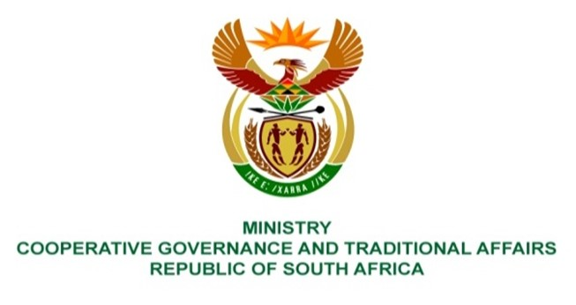

NATIONAL ASSEMBLY
QUESTION FOR WRITTEN
QUESTION NUMBER 3839
DATE OF PUBLICATION: 21 OCTOBER 2022

QUESTION:

3839. Ms E R J Spies (DA) to ask the Minister of Cooperative Governance and Traditional Affairs:

- With reference to a presentation on the 2021-22 audit outcomes to the Portfolio Committee on Cooperative Governance and Traditional Affairs, wherein the Auditor-General made the finding that project management fees were paid under the Community Works Programme to implementing agents of the Contract Work Programme from April 2018 to March 2021, without evidence of goods and services having been received due to ineffective internal controls for approving and processing payments, what total amount was paid in irregular project management fees to the implementing agents;
- whether any steps have been taken to recover the irregular payments; if not, why not; if so, what total amount has been recovered; if so, what total amount has been recovered;
- whether any of the implementing agents were blacklisted from doing business with her department; if not, why not; if so, what are the relevant details? NW4736E

REPLY:

- The balance of overpaid project management fees to two Non-Profit Oganisations (NPOs) was R1 820 519,18 as at 31 March 2022.

- The amount has been offset against retained project management fees due to the NPOs, leaving a balance of R287 305,79 due by one (1) NPO to the Department. This NPO is no longer in business and the Department’s attorneys are currently tracing the former Directors of the NPO in order to commence litigation.

- The Department has engaged the National Treasury through the Chief Procurement Officer on a number of Community Works Programme (CWP) related matters, including the possible blacklisting of NPOs found to be in breach of their Service Level Agreements (SLAs). The discussions with the National Treasury are ongoing.

