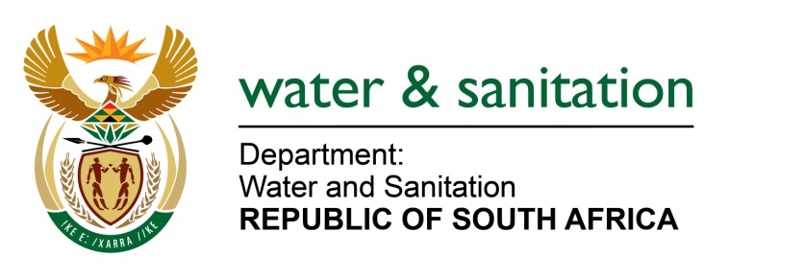

NATIONAL ASSEMBLY

FOR WRITTEN REPLY

QUESTION NO 3838

DATE OF PUBLICATION IN INTERNAL QUESTION PAPER: 23 OCTOBER 2015
(INTERNAL QUESTION PAPER NO. 41)

3838. Mr C D Matsepe (DA) to ask the Minister of Water and Sanitation:
(1) What is the difference between her department’s War on Leaks programme and the Unemployed Youth Skills Development project;
(2) (a) what is the current budget allocation for the Unemployed Youth Skills Development project, (b) how many persons are currently trainees in the specified project, (c) in which municipalities are the specified persons employed, (d) how many (i) males and (ii) females are part of the specified project, (e) what is their remuneration and (f) what (i) specific skills are being transferred and (ii) are the terms and conditions of employment? NW4584E
---00O00---
REPLY:

(1) The War on Leaks project aims to decrease water leaks by training unemployed
youth / citizens to improve the overall water use efficiency within municipalities, communities and households whereas the objective of the unemployed youth skills development project is to support South African youth with skills development and opportunities to community service. The unemployed youth skills development project is run by the Department of Public Works and the National Youth Development Agency.

(2)(a) Requesting the Honorable member to refer the question to the Minister of Public Works who will be in a better position to respond to these questions on the Unemployment Skills Development project.

---00O00---

