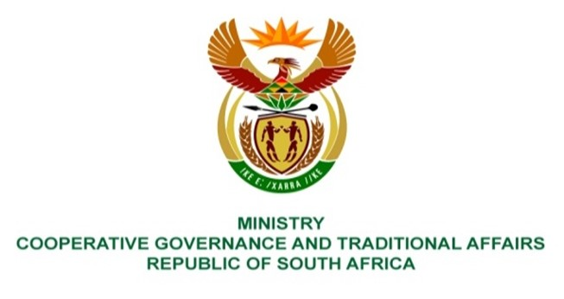

NATIONAL ASSEMBLY
QUESTION FOR WRITTEN REPLY
QUESTION NUMBER 3837
DATE OF PUBLICATION: 21 OCTOBER 2022

QUESTION:

3837. Ms E R J Spies (DA) to ask the Minister of Cooperative Governance and Traditional Affairs:

- With reference to a presentation on the 2021-22 audit outcomes for the Portfolio Committee on Cooperative Governance and Traditional Affairs, wherein the Auditor-General made the finding that payments were made in the 2018-19 financial year under the Community Works Programme to non-qualifying government employees due to ineffective internal controls for approving and processing payments, what total amount was paid to the non-qualifying government employees;
- whether any steps have been taken to recover the irregular payments; if not, why not; if so, what (a) total amount has been recovered and (b) disciplinary action has been taken against government employees who irregularly benefited from the CWP? NW4734E

REPLY:

- The total unconfirmed (maximum) amount of Community Works Programme (CWP) stipends paid to possible non-qualifying government employees for the period 1 April 2018 to 31 March 2020 was R6 300 997,00. This unconfirmed amount involves about 534 government employees in 62 national and provincial departments.

- The Director-General of the Department of Cooperative Governance (DCoG) in January 2022 wrote letters to the Directors-General and Heads of Department of all 62 departments to investigate the matter and to either confirm the allegations of double-dipping or to provide evidence to clear findings. To date 25 departments responded to all findings and 37 departments have responded either partially or not at all. Findings to the value of R369 640,50 have been cleared and findings to the value of R980 290,50 have been confirmed. Of the confirmed findings, R769 226,00 is in the process of being recovered and R183 447,00 has been written off since the individuals have left government and are also no longer participating in the CWP. Litigation through the State Attorney is not economical as the individual amounts are small.

  - R12 090,00 has been recovered to date.

  - The Department cannot take disciplinary action directly against or recover funds from persons employed by other government departments. It is the responsibility of the respective Accounting Officers to take disciplinary action and to recover funds. The Auditor-General has been requested to also provide the details of findings to the audit managers of the 62 Departments to ensure that Accounting Officers take the necessary action.

