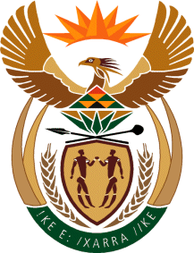

MINISTRY: COMMUNICATIONS
REPUBLIC OF SOUTH AFRICA
Private Bag X 745, Pretoria, 0001, Tel: +27 12 473 0164 Fax: +27 12 473 0585
Tshedimosetso House,1035 Francis Baard Street, Tshedimosetso House, Pretoria, 1000

NATIONAL ASSEMBLY
QUESTION FOR WRITTEN REPLY
QUESTION NUMBER: 3832 OF 2015
DATE OF PUBLICATION: 23 OCTOBER 2015

Ms V van Dyk (DA) to ask Minister of Communications:
(a) What percentage of the Media Development and Diversity Agency funding is allocated to (i) print media and (ii) electronic media per annum and (b) what is the reason for giving any of the specified categories more funding as compared to others?
___________________________________________________________________
REPLY: MINISTER OF COMMUNICATIONS

(a) Subject to sub-regulation (2), of Section 22 of the MDDA Act 14 of 2002, funds contemplated in section 15(2)(a) of the Act must be allocated by the Board in accordance with the following percentages:
- Community media projects: at least 60%
- Small Commercial media projects: at least 25%
- Research projects: 5%

(b) The reason for giving community media projects more funding is informed by Regulations in terms of Section 22 of the Media Development and Diversity Agency Act of 2002, as enacted in the Government Gazette No. 22570 of 10 October 2003.

MR NN MUNZHELELE
DIRECTOR GENERAL [ACTING]
DEPARTMENT OF COMMUNICATIONS
DATE:

MS AF MUTHAMBI (MP)
MINISTER OF COMMUNICATIONS
DATE

