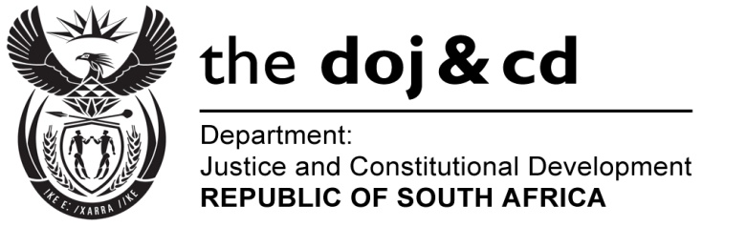

NATIONAL ASSEMBLY
QUESTION FOR WRITTEN REPLY
PARLIAMENTARY QUESTION NO.: 3830
DATE OF QUESTION: 23 OCTOBER 2015
DATE OF REPLY: 6 NOVEMBER 2015

3830. Mr M S Malatsi (DA) to ask the Minister of Justice and Correctional Services:

Has he or his department contacted or been contacted by any organ of state of the United States of America (USA) in respect of the ongoing investigation and indictment into allegations of corruption with regard to the Fifa 2010 Soccer World Cup Tournament; if not, why has he not contacted any USA organ of state in this regard; if so, in each case, (a) when and (b) what are the relevant details of such communication? NW4576E

REPLY:
I wish to inform the Honourable Member that yes, I and the Department of Justice and Constitutional Development have received a communication from the Legal Attaché of the United States Federal Bureau of Investigation (FBI) in South Africa in this regard.

(a) During June 2015, the Legal Attaché (FBI) in South Africa, forwarded a letter to the Department, attaching a copy of an indictment related to the FIFA matter.

(b) The purpose of the letter was to bring the contents of the indictment under the attention of the Department. It was also stated in the letter that the FBI was looking forward to the continued partnership between the FBI, the American Department of Justice and the South African Department of Justice and Constitutional Development.

The Department submitted the letter to me in a memorandum, informing me of the contents of the letter as well as the indictment. I was also informed that a formal request for assistance has not yet been received from the American authorities. I noted the contents of the memorandum, including the indictment, and forwarded copies of the indictment to the Inter-Ministerial Committee on Corruption, the Minister of Sport and Recreation, the Department of International Relations and Cooperation and the Chairperson of the Anti-Corruption Task Team (ACTT).
.

