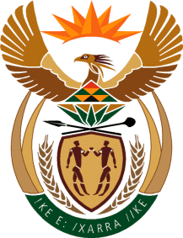

MINISTRY OF TOURISM
REPUBLIC OF SOUTH AFRICA

Private Bag X424, Pretoria, 0001, South Africa. Tel. (+27 12) 444 6780, Fax (+27 12) 444 7027
Private Bag X9154, Cape Town, 8000, South Africa. Tel. (+27 21) 469 5800, Fax: (+27 21) 465 3216

NATIONAL ASSEMBLY:

QUESTION FOR WRITTEN REPLY:
Question Number: 383
Date of Publication: 19 February 2021
NA IQP Number: 2
Date of reply: 04 March 2021

Mr M S F de Freitas (DA) to ask the Minister of Tourism:
With reference to the opening of international borders, what (a) are the plans to engage National Treasury to obtain more of the budget and (b) would be the main requirements for the budget? NW389E

REPLY:

The Department of Tourism, as is the case with all other organs of state at a national level, make budget requirements and motivation submissions to the National Treasury within the medium term expenditure framework (MTEF) cycle which concludes with the budget speech prior to the finalisation of the Annual Performance Plans (APPs). Thus the Department and its entity, South African Tourism ensures that the APPs are within the financial means available in terms of the MTEF allocations.

- and (b) Not applicable

