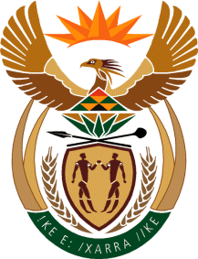

MINISTRY OF TOURISM
REPUBLIC OF SOUTH AFRICA

Private Bag X424, Pretoria, 0001, South Africa. Tel. (+27 12) 444 6780, Fax (+27 12) 444 7027
Private Bag X9154, Cape Town, 8000, South Africa. Tel. (+27 21) 469 5800, Fax: (+27 21) 465 3216

NATIONAL ASSEMBLY:

QUESTION FOR WRITTEN REPLY:
Question Number: 382
Date of Publication: 19 February 2021
NA IQP Number: 2
Date of reply: 04 March 2021

Mr M S F de Freitas (DA) to ask the Minister of Tourism:
With reference to the focus on tourism from African countries, (a) which countries in particular will be prioritised, (b) what (i) criteria and (ii) data was used for such prioritisation, (c) what will be done to develop and grow the markets and (d) what are the (i) focus market segments, (ii) timelines, milestones and deadlines per market segment and (iii) budgets per market segment? NW388E

REPLY:
- Markets of key focus in 2021/22 fiscal are: Nigeria; Kenya; Zambia; Malawi; Mozambique; Zimbabwe; eSwatini; Lesotho; Botswana and Namibia.

- (i) and (ii) An in-depth analysis to determine priority markets for marketing investment in the next 3-5 years was undertaken in mid-2020 and concluded by the end of 2020. The process considers data availability for the decision-making, size of travel market, attractiveness characteristics, and ability to attract it to travel to the destination.

- Key focus in the continent in the upcoming financial year will be on driving brand positivity messaging through the new regional campaign and also to capacitate both the source market trade and South African Product Owners.

(d) (i) –( iii) Detailed plans for the financial year 2021/22 shall be based on Annual Performance Plan that is still to be tabled.

