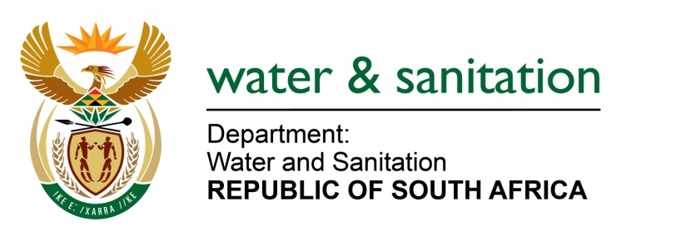

NATIONAL ASSEMBLY

FOR WRITTEN REPLY

QUESTION NO 3815

DATE OF PUBLICATION IN INTERNAL QUESTION PAPER: 23 OCTOBER 2015
(INTERNAL QUESTION PAPER NO. 41)

3815. Mr H C C Krüger (DA) to ask the Minister of Water and Sanitation:
Has her department complied with all the recommendations made in the SA Human Rights Commission report, report number MP/2011/0134 in respect of the Emalahleni Local Municipality in Mpumalanga; if not, (a) why not and (b) what measures will she take to ensure urgent compliance by the relevant officials of her department; if so, what are the relevant details? NW4559E
---00O00---
REPLY:
Yes my Department did comply with recommendations of the SA Human Rights Commission Report. During 2011/2012 financial year the Department provided training on process control to Emalahleni Local Municipality, extending to all Water Services Authority (WSA) within the Mpumalanga Province. In addition to the training provided the Department undertakes annual symposia on water quality compliance training as part of the blue drop compliance assessment process. The most recent symposium on the assessment tool were held from 30 - 31 July 2015.
As recommended by the report, the Department undertakes regular water quality compliance monitoring aimed at determining the safety of water for human use. The supply and infrastructure monitoring is carried through the blue drop assessment programme.
---00O00---

