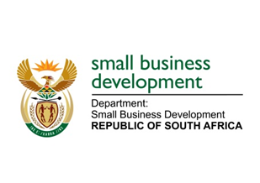
NATIONAL ASSEMBLY

QUESTION FOR ORAL REPLY

“3809. Mr R W T Chance (DA) to ask the Minister of Small Business Development:

Whether the forensic investigation into allegations of corruption and mismanagement in her department that was commissioned by the Auditor-General has been completed; if not, by what date is the investigation envisaged to be completed; if so, (a) on what date was the investigation completed and (b) what are the main findings of the investigation?”
NW4386E

REPLY:

The investigation has not been completed. The Auditor-General has informed the Department of Small Business Development (DSBD) that the envisaged completion timeline for the investigation is early 2019.

- The investigation was envisaged to be completed by 10 September 2018.
- Findings will be known once the investigation report is issued.

