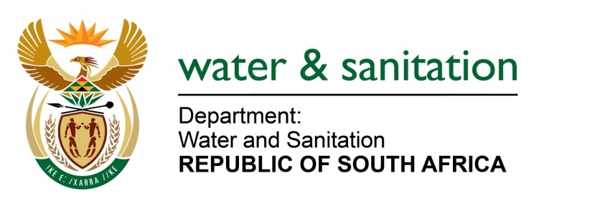

NATIONAL ASSEMBLY

FOR WRITTEN REPLY

QUESTION NO 3809

DATE OF PUBLICATION IN INTERNAL QUESTION PAPER: 23 OCTOBER 2015
(INTERNAL QUESTION PAPER NO. 41)

3809. Mr L J Basson (DA) to ask the Minister of Water and Sanitation:
(1) With regard to the contract for water rights signed between the Lepelle Northern Water Board and Southern Palace 440 (Pty) Ltd in 2012, (a) what is the extent of the specified contract, (b) what is the period of the contract and (c) did the contract go out on tender; if not, why not; if so, what (i) is the tender number and (ii) are the names of the other parties who submitted tenders;
(2) was this contract ever investigated by her department; if not, why not; if so, (a) what was the outcome of the investigation, (b) did her department take any steps in this regard and (c) is the contract valid;
(3) (a) what is the price per cubic metre at which water is sold to the specified company, (b) how is the specified company’s usage measured and (c) at what price does the specified company resell the water;
(4) (a) when did the specified contract start, (b) how many cubic metres of water in total has been sold to the specified company by the end of September 2015 and (c) does the specified company owe any money to the Lepelle Northern Water Board;
(5) whether her department approved the specified contract; if not, why not; if so, (a) who approved the specified contract, (b) when was it approved and (c) can she supply the approval letter? NW4553E
---00O00---
REPLY:
(1)(a) The contract referred to is a bulk water supply contract.

(1)(b) The duration of the contract is for 30 years.

(1)(c) The contract did not go out on tender. My Department allocates water to Water Boards in general, the Water Board (Lepelle Northern Water in this instance) needs to find clients who will utilise such allocation and alternatively other businesses approach LNW to check if the board can meet their demands for either their expansion or extension or starting up a business.

The above is not done through the form of a tender but through water supply agreements between its customers, whether it is industries or Municipalities in LNW’s area of supply.

(2) No, there was no need as this was a normal bulk water supply agreement between LNW and Southern Palace 440 (Pty) Ltd.The contract is valid but has outstanding suspensive conditions which have not yet been agreed to.

(3)(a) R0, 07658 cents per m3 adjustable annually,

(3)(b) Through meters.

(3)(c) The water was intended for Agricultural purposes.

(4) The contract has not been implemented.

(5) No, my Department does not approve agreements, the LNW signs agreements with clients, in line with the delegations of authority.

---00O00---

