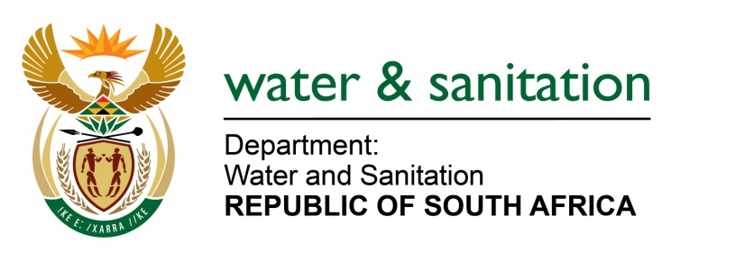

NATIONAL ASSEMBLY

FOR WRITTEN REPLY

QUESTION NO 3808

DATE OF PUBLICATION IN INTERNAL QUESTION PAPER: 23 OCTOBER 2015
(INTERNAL QUESTION PAPER NO. 41)

3808. Mr L J Basson (DA) to ask the Minister of Water and Sanitation:
(1) With regard to the Mokolo and Crocodile Water Augmentation Project for abstraction works and pump station in the west side of the Crocodile River near Thabazimbi and the pipeline to Steenbokpan and Lephalale, what is the (a) progress and (b) time frame for the completion of the (i) environmental impact assessment and (ii) engineering design of the specified (aa) project and (bb) pipeline;
(2) how many million cubic metres of water will be required;
(3) (a) when will construction start and (b) what is the (i) envisaged completion date and (ii) total cost of the specified project;
(4) is Eskom making a contribution to the cost of the specified project; if not, why not; if so, (a) what amount and (b)(i) when and (ii) how will payment be made? NW4552E
---00O00---
REPLY:
(1) Mokolo and Crocodile Water Augmentation Project 2 is at the planning stage. The Environmental Impact Assessment (EIA) process started in July 2015 with the appointment of an EIA consultant. In parallel, DWS is finalising the Post Feasibility Bridging Study Report. This will be used as input to inform the design process. The EIA is planned for completion in January 2017. Engineering designs for both the project and the pipeline are expected to be completed in September 2016, if the design starts in November 2015.

(2) The provisional approved capacity is 75 million cubic meters per year.

(3) Construction is envisaged to start in September 2017.The envisaged completion date is September 2023, but the Water Delivery is envisaged for May 2022. The capital cost of the project is budgeted at R 12 000 million.

(4) Yes, the project is largely to be funded off-budget through loans raised by TCTA. Eskom is an off-taker whereby they commit in a water supply agreement to contribute to the cost of the project for their proportional off-take from the system through water tariffs.

Furthermore, the Department of Energy is standing in for the future energy users to ensure that the infrastructure is sized appropriately to meet the demands of future users.
---00O00---

