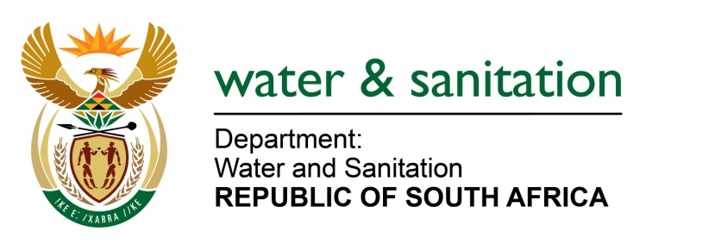

NATIONAL ASSEMBLY

**FOR WRITTEN REPLY**

**QUESTION NO 3807**

**DATE OF PUBLICATION IN INTERNAL QUESTION PAPER: 23 OCTOBER 2015**

**(INTERNAL QUESTION PAPER NO. 41)**

**3807. Mr L J Basson (DA) to ask the Minister of Water and Sanitation:**

(1) (a) What royalties are paid to Lesotho for the Lesotho Highlands Water Project and (b) how are the specified royalties calculated;

(2) what was the (a) fixed tariff royalty, (b) price of water per cubic meter and (c) total amount of water used in each year since 2000;

(3) is there a sliding scale on royalties for the next 10 years; if not, why not; if so, (a) why and (b) what are the relevant details of the specified sliding scale? NW4551E

---00O00---

**REPLY:**

(1) Royalties, as defined in the Treaty, are paid to the Government of Lesotho for the benefit of receiving South Africa’s share of the yield from the Orange River through the Lesotho Highlands Water Project (LHWP), a gravity scheme, rather than through the least cost Orange-Vaal Transfer Scheme (OVTS), a pumping scheme wholly located within South Africa. Royalties are based on the amount of water actually delivered and correspond to 56% of the capital, operation and maintenance and pumping electricity cost savings realised by Republic of South Africa (RSA) through the implementation of the LHWP water transfer component rather than the costlier next best Orange Vaal Transfer Scheme.

In terms of Article 12, Paragraph (10) of The Treaty between Government of the Republic of South Africa and the Kingdom of Lesotho, royalties comprise of a fixed and a variable component. The cost savings on capital costs are referred to as fixed royalties since a fixed amount in real terms is paid out as royalties every month. The compensation will be for fifty years and commenced from January 1995.

The variable portion is related to the cost savings on O&M costs and amounts related to the pumping electricity cost savings and these amounts depend on water actually delivered to RSA. The variable component is based on the volume of water delivered to South Africa and is made up of the net benefit on being able to gravitate from LHWP rather than pumping from OVTS. It comprises:

* The difference in electricity costs. This component is adjusted on a monthly basis in accordance with the Producer Price Index (PPI) and corrected on a yearly basis when the Eskom selling price of electricity becomes available (usually in October of every year), and
* The difference in operation and maintenance costs, which is also adjusted on a monthly basis in accordance with the PPI.

(2) Refer to table below. Please note that the price per cm3 for both the O&M and the electricity is determined on a monthly basis due to the monthly PPI adjustments, the amounts reflected below are therefore the average price for the year.



(3) No, there is no sliding scale. The royalties are calculated as per (1) above as stipulated in the Treaty.

---00O00---