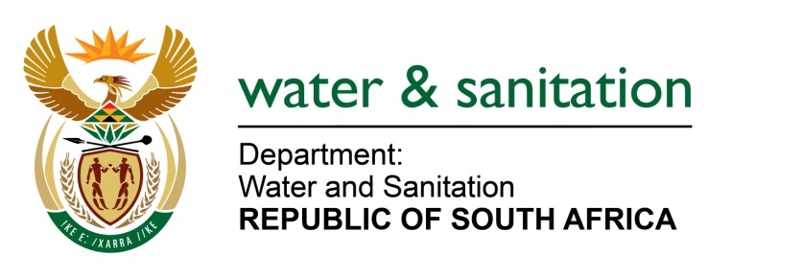

NATIONAL ASSEMBLY

FOR WRITTEN REPLY

QUESTION NO 3801

DATE OF PUBLICATION IN INTERNAL QUESTION PAPER: 21 OCTOBER 2022
(INTERNAL QUESTION PAPER NO. 40)

3801. Mrs V van Dyk (DA) to ask the Minister of Water and Sanitation:

(1) (a) What water sources do the mining companies in Koingnaas in the Kamiesberg Local Municipality use for mining purposes and (b) do the mining companies use any water from the Somnaas-Noup aquifer in the specified municipality.

(2) what companies applied for water licences in the specified area.

(3) whether any water licences were granted to the mining companies; if not, why not; if so, (a) to whom were the licences granted, (b) what were the specifications of each licence and (c) on what date was each licence granted.

(4) whether an environmental impact study has been conducted to ensure what the effect of mining will be on the (a) water tables of the area, specifically Somnaas-Noup aquifer and (b) town of Koingnaas;

(5) whether he will furnish Mrs V van Dyk with a copy and/or copies of the licence(s) issued; if not, why not; if so, what are the relevant details?

NW4694E
---00O00---

MINISTER OF WATER AND SANITATION
- Groundwater is the main source of water for domestic supply in the region. The settlements of Koingnaas, Hondeklip Bay and Samson Bak derive water from the Somnaas Noup aquifer located about 20 km north of Koingnaas. Two boreholes, BH 12 and BH 14, are currently in use. A third borehole, BH15 adjacent to BH 12, is equipped and used as a standby borehole.

- the mining companies use water from the Somnaas-Noup aquifer in the specified municipality.

(2) West coast Resources Pty Ltd: Namaqualand Mine applied for a water use licence which was issued on 23 June 2017. Conditions of the licence includes the following:
- Monitoring: The licensee should establish ground water network monitoring within 1 year from the date of issuance of licence.
- Water Conservation and Water Demand management (WC/WDM): The licensee shall develop WC/WDM and submit to Provincial Head or responsible authority, which amongst other should quantify the water use efficiency of the activity.
- The WC/WDM shall be updated annually and submitted to Provincial Head or responsible authority.
- The licensee shall provide any water user whose water supply is impacted by use with potable water

(3) Please refer to the response above.

(4) It is a prerequisite for any mining licence holder to conduct an environmental impact study to ensure what the effect of mining will be on the water resources. A report on geohydrological impact assessment for West Coast Resources Diamond mining operations along the west coast around Koingnaas, Northern Cape province: was concluded in 2016 with a Ref number: 2016/ENV008, dated July 2016, amongst others the report made the following reference “Groundwater represents the main source of water for domestic supply in the region. The settlements of Koingnaas, Hondeklip Bay and Samson Bak derive water from the Somnaas Noup aquifer located about 20 km north of Koingnaas. Two boreholes, BH 12 and BH 14, are currently in use. A third borehole, BH15 adjacent to BH 12, is equipped and used as a standby borehole”.

a-b) For the town of Koingnaas, the report made the following reference:
- Available water quality data indicate that the entire area proposed for mining is characterised by highly saline groundwater with electrical conductivity of above 1000 mS/m. This is supported by the fact that there are no water supply boreholes around, and south of Koingnaas. Potable groundwater is currently sourced from the Somnaas Noup aquifer located about 20 kilometres north of Koingnaas.

(5) A copy of the licence is attached as Annexure A.

