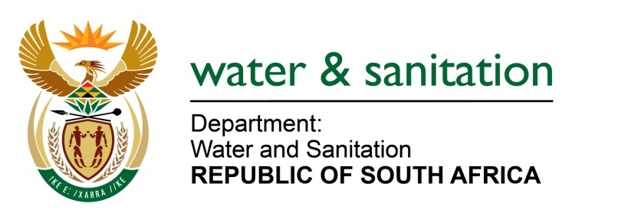

NATIONAL ASSEMBLY

FOR WRITTEN REPLY

QUESTION NO 3773

DATE OF PUBLICATION IN INTERNAL QUESTION PAPER: 21 OCTOBER 2022
(INTERNAL QUESTION PAPER NO. 40)

3773. Mrs M R Mohlala (EFF) to ask the Minister of Water and Sanitation:
Whether he has engaged with Eskom to exclude water treatment works from load shedding in the various municipalities, as it has a negative impact on service delivery; if not, why not; if so, what are the relevant details?
NW4661E
---00O00---

MINISTER OF WATER AND SANITATION

Engagement is ongoing with the respective Water Service Authorities regarding the need to provide alternative energy supply mechanisms that can minimize the impact of loadshedding, to ensure the citizens constitutional right of access to clean drinking water.

Supported by the department, Water Boards, in their roles as water service providers to water service authorities, have taken different approaches to manage the impact of ESKOM’s loadshedding on their ability to provide reliable bulk water supply services to users, including:

- Engaging with the provincial government leadership and ESKOM in an attempt to negotiate and facilitate for exemption on water infrastructure from frequent load-shedding
- Filing applications with ESKOM for exemption in terms of Eskom Regulation NRS048-9. Some applications for exemption have been successful while some have not been due to technical reasons advanced by ESKOM and some are still waiting for outcomes to the applications.
- Entities such as Bloem Water, Rand Water, Umngeni Water, Lepelle Water and Magalies Water are operating water infrastructure that is exempt from loadshedding and are mostly able to continue with operations.
- Where affordable, some of the entities have procured back-up generators to continue with operations even when there is loadshedding

---00O00---

