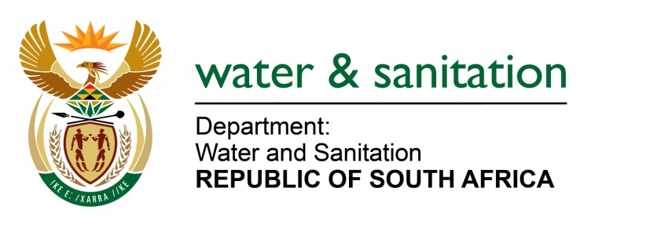

NATIONAL ASSEMBLY

FOR WRITTEN REPLY

QUESTION NO 3772

DATE OF PUBLICATION IN INTERNAL QUESTION PAPER: 21 OCTOBER 2022
(INTERNAL QUESTION PAPER NO. 40)

3772. Mrs M R Mohlala (EFF) to ask the Minister of Water and Sanitation:
What steps of intervention has his department taken to address the trend which reflects that it manages to spend a large part of its appropriations, but the actual achievement of its targets is far below?
NW4660E
---00O00---

MINISTER OF WATER AND SANITATION

The correlation between performance information and expenditure is a complex matter as the annual performance plan (APP) that is designed to track performance does not necessarily monitor all expenditure items of the Department. The APP is designed to measure activities of strategic importance within a given period even though some activities may have little cost implications.

In an effort of aligning the performance with expenditure, the departmental activities that have the highest budget have several indicators, for example the Regional Bulk Infrastructure and Water Services Infrastructure Grants. The Department is continually improving processes that result in inefficiencies and contribute to the low performance (a case in point is the procurement processes).

---00O00---

