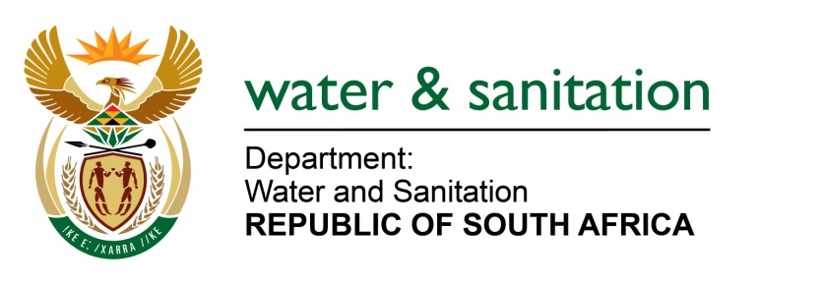

NATIONAL ASSEMBLY

FOR WRITTEN REPLY

QUESTION NO 377

DATE OF PUBLICATION IN INTERNAL QUESTION PAPER: 16 FEBRUARY 2018
(INTERNAL QUESTION PAPER NO. 2)

377. Ms T M Mbabama (DA) to ask the Minister of Water and Sanitation:
(a) What is the total amount that was (i) budgeted for and (ii) spent on her private office (aa) in each of the past three financial years and (bb) since 1 April 2017 and (b) what was the (i) remuneration, (ii) salary level, (iii) job title, (iv) qualification and (v) job description of each employee appointed in her private office in each of the specified periods? NW399E

---00O00---
REPLY:
- (i) The private office does not have a separate budget from that of the Ministry.
The budget and the expenditure of the private office is included in the budget of the Ministry which is reflected in the Annual Reports of the 2014/15, 2015/16 and the 2016/17 financial years
- The remuneration of employees in the private office is included in the compensation of all employees in the department as reflected in the relevant annual reports.
The salary levels and job descriptions are in line with the guidelines provided by the Handbook for Members of the Executive as well the Public Service Regulations.
---00O00---

