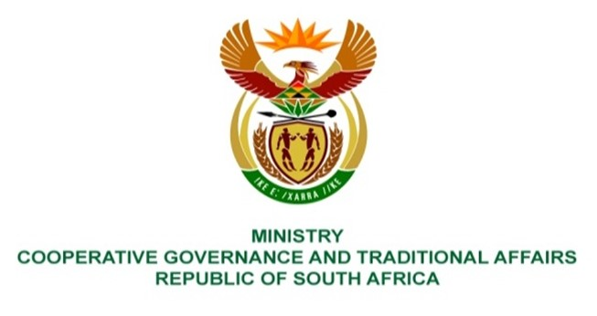

NATIONAL ASSEMBLY
QUESTION FOR WRITTEN REPLY

QUESTION NUMBER 3764
DATE OF PUBLICATION: 21 OCTOBER 2022

QUESTION:

3764. Mr K Ceza (EFF) to ask the Minister of Cooperative Governance and Traditional Affairs:
What remedial action has she taken to ensure the availability of necessary machines to exhume the outstanding bodies in the KwaZulu-Natal floods? NW4652E
REPLY:
It is the competency of South African Police service to conduct exhumation of bodies. It is recommended that this question be redirected to Ministry of Police to respond accordingly.

