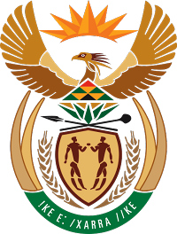

**MINISTRY FOR COOPERATIVE GOVERNANCE AND TRADITIONAL AFFAIRS**

**REPUBLIC OF SOUTH AFRICA**

**NATIONAL ASSEMBLY**

**QUESTIONS FOR WRITTEN REPLY**

**QUESTION NUMBER 2015/3763**

**DATE OF PUBLICATION: 16 OCTOBER 2015**

**Mr M Hlengwa (IFP) to ask the Minister of Cooperative Governance and Traditional Affairs:**

1.Since his reply to question 1373 on 11 May 2015 (a) what total amount do national and provincial departments owe to municipalities in unpaid services such as rates and taxes and (b) what amount of the specified debts is (i) 30 days, (ii) 60 days, (iii) 90 days and (iv) 120 or more days overdue;

(2) What is (a) the total interest charged and (b) he doing to ensure that the specified debts are settled?

**REPLY**

1. The total owed by national and provincial departments to municipalities in unpaid services and rates amounts to R4.7 billion as at June 2015.

(b).The debtor’s age analysis is as follows



2. (a) The total interest charged amounts to R 291 million

(b) In ensuring that the specified debt is settled; the department participates in an inter-governmental task team that has been established to expedite the payment of debt owed by government departments to municipalities. This task team is led by the Department of Public Works.

Through the work of the task team we moved to a point where Government is improving the payment of current debt that is undisputed. The remaining challenge is older arrear debt and disputed current debt.

To accelerate payment and mitigate against disputed invoices, the Department of Public Works has employed a service provider (managed at DPW) to conduct the verification and authentication of invoices.

FOSAD has also resolved that while the debt is in disputes, departments must pay a minimum of 80% of their disputed debt whilst they are still querying it with the municipality and when verified can either be paid in full or credited to their account later on.