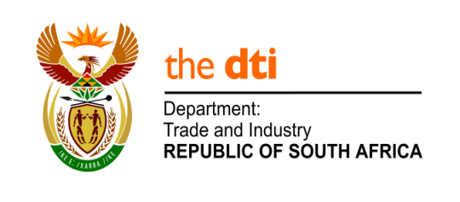

NATIONAL ASSEMBLY

WRITTEN REPLY

PARLIAMENTARY QUESTION 376

DATE OF PUBLICATION: 26 JULY 2019

Mr H S Gumbi (DA) to ask the Minister of Trade and Industry:
What (a) number of official international trips is (i) he and (ii) his deputies planning to undertake in the 2019-22 medium term expenditure framework, (b) will the (i) destination, (ii) date, (iii) purpose and (iv) number of persons who will travel with the delegation be and (c) is the detailed breakdown of the expected cost of (i) flights, (ii) accommodation and (iii) any other expenses in each case? NW1348E

Reply:

The Ministry is required to undertake international travel to carry out the core mandate on trade, industry and competition. These will normally focus on areas such as export promotion, investment promotion and showcasing South African products and companies, participation at Summits with economic partners, participation in international trade negotiations, attendance at multilateral economic engagements and bilateral relations missions and promoting economic South Africa’s interests.

At the request of the President, the Minister and Deputy Ministers may be requested to attend to international engagements and accompany the President and/or Deputy President on State and Working visits abroad, in accordance with the protocols normally followed by national states.

International travel is not planned three years in advance. Costs pertaining to international travel is provided in the Annual Reports for the specific year concerned. Attendance by officials will depend on the nature of the national economic interests being pursued during a given visit and the nature of the events and engagements.

-END-

