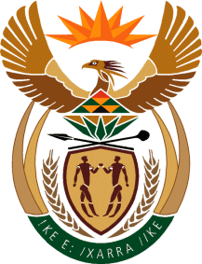

MINISTRY OF TOURISM
REPUBLIC OF SOUTH AFRICA

Private Bag X424, Pretoria, 0001, South Africa. Tel. (+27 12) 444 6780, Fax (+27 12) 444 7027
Private Bag X9154, Cape Town, 8000, South Africa. Tel. (+27 21) 469 5800, Fax: (+27 21) 465 3216

Ref: Ref: TM 2/1/1/10

QUESTION FOR WRITTEN REPLY:
Question Number: 376
Date of Publication: 3 March 2017
NA IQP Number: 1
Date of reply: 9 March 2017

Mr M W Rabotapi (DA) to ask the Minister of Tourism:

What is the (a) make, (b) model, (c) price and (d) date on which each vehicle was purchased for use by (i) him and (ii) his deputy (aa) in the (aaa) 2014-15 and (bbb) 2015-16 financial years and (bb) since 1 April 2016 NW429E
Reply:
- Minister

No vehicles were purchased for the Minister during 2014/15 and 2015/2016 Financial Years

- Deputy- Minister

 | Year | (a)Make | (b)Model | (c ) Price | (d)Date
(aa)  Financial Year | (aaa) 2014-2015 | Audi Q7 TDI  (Pretoria)  Mercedes Benz  (Cape Town) | 2014  2014 | R878 701.47  R762 443.19 | 17 January 2015  19 February 2015
 | (bbb) 2015-2016 | None | N/A | N/A | N/A
(bb) Since | 1 April 2016 | None | N/A | N/A | N/A

