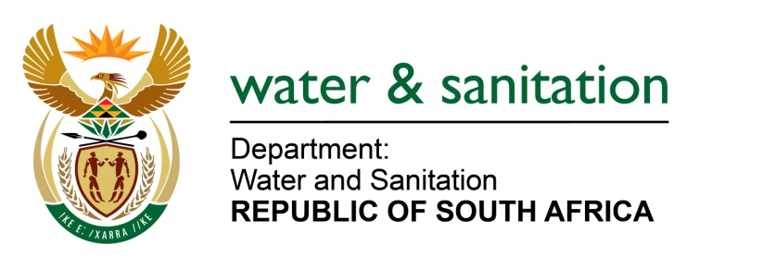

NATIONAL ASSEMBLY

FOR WRITTEN REPLY

QUESTION NO 3756

DATE OF PUBLICATION IN INTERNAL QUESTION PAPER: 17 NOVEMBER 2017
(INTERNAL QUESTION PAPER NO. 44)
3756. Ms M S Khawula (EFF) to ask the Minister of Water and Sanitation:
(1) Whether (a) her department and/or (b) entities reporting to her procured services from a certain company (name furnished); if so, (i) what services were procured in each case and (ii) what is the total amount that was paid to the specified company in each case;
(2) whether the specified company provided services related to international travel to (a) her department and/or (b) entities reporting to her; if so, (i) what is the name of each person who travelled, (ii) what was the travel route and (iii) what is the total amount that was paid for each person? NW4250E
---00O00---
REPLY:
- None

- My Department has not used Travel with Flair services 2016- 2017 for Main Account and Water Trading Entity (WTE).
---00O00---

