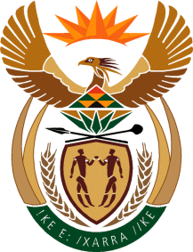

MINISTER OF TOURISM
REPUBLIC OF SOUTH AFRICA

Private Bag X424, Pretoria, 0001, South Africa. Tel. (+27 12) 444 6780, Fax (+27 12) 444 7027
Private Bag X9154, Cape Town, 8000, South Africa. Tel. (+27 21) 469 5800, Fax: (+27 21) 465 3216

NATIONAL ASSEMBLY:

QUESTION FOR WRITTEN REPLY:
Question Number: 375
Date of Publication: 26 July 2019
NA IQP Number: 6
Date of reply: 30 August 2019

Dr MM Gondwe to ask the Minister of Tourism:
What (a) number of official international trips is (i) she and (ii) her deputy planning to undertake in the 2019-22 medium term expenditure framework, (b) will the (i) destination, (ii) date, (iii) purpose and (iv) number of persons who will travel with the delegation be and (c) is the detailed breakdown of the expected cost of (i) flights, (ii) accommodation and (iii) any other expenses in each case?

Reply:
- Number of international trips planning to undertake in 2019-22
Government is currently in the process of concluding MTSF and MTEF 2020 -2025, once this is concluded the department will conclude its plans and budget.

- N/A
- N/A
- N/A
- N/A

