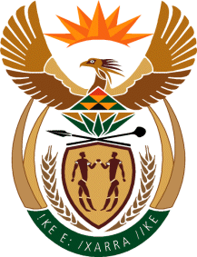

MINISTER IN THE PRESIDENCY: REPUBLIC OF SOUTH AFRICA
Private Bag X1000, Pretoria, 0001, Union Buildings, Government Avenue, PRETORIA
Tel: (012) 300 5200, Website: www.thepresidency.gov.za

NATIONAL ASSEMBLY

QUESTION FOR WRITTEN REPLY

QUESTION NUMBER: 375

Mr H B Groenewald (DA) to ask the Minister in The Presidency:
With reference to President Jacob G Zuma’s undertaking in his State of the Nation Address delivered on 12 February 2015, that the Government will set aside 30% of appropriate categories of state procurement for purchasing from Small, Medium and Micro-sized Enterprises (SMMEs), co-operatives, as well as township and rural enterprises, what percentage of the total procurement of (a) the Office of the Presidency and (b) every entity reporting to him went to (i) SMMEs and (ii) co-operatives from 1 April 2015 up to the latest specified date for which information is available? NW387E

replY:

The Presidency procured 44%, and the Department of Planning Monitoring and Evaluation procured 22.8% from SMMEs in the period in question.

