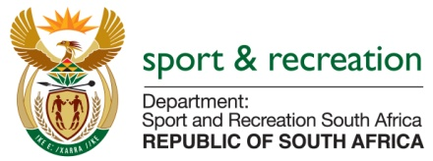

PARLIAMENTARY QUESTION FOR THE MINISTER

QUESTION NUMBER 3744

QUESTION 3744

Mr M S Malatsi (DA) to ask the Minister of Sport and Recreation:
With reference to a technical report on the performance of Bafana Bafana at the 2015 Africa Cup of Nations, (a) when did he or his department commission the specified report, (b) what amount was (i) budgeted for and (ii) spent on the report, (c) which service providers were appointed to produce the report and (d) what are the relevant details of the specified service providers including (i) their names, (ii) physical addresses and (iii) chief executive officers? NW4428E

REPLY
SAFA routinely interrogates the coaches' reports through its Technical Committee and has done so at the March 2015 Technical Committee meeting.

SAFA also received an independent expert technical analysis of all 3 matches at the 2015 Africa Cup of Nations Final Tournament in Equatorial Guinea and has discussed it thoroughly with a view to making corrections for future matches.

SAFA has its own internal match analysis system which it has used for all national teams.

b) No government funds were used for Bafana Bafana at any time during this period. The independent technical analysis was done by an international match analyst engaged by SAFA;

c) Government did not use any service providers. Instead, SAFA engaged the independent technical analysts who were vying for a long-term relationship with the Association. They produced their analysis to indicate the strengths of their system. SAFA deems its own system to be of equal value and continues to use its own match technical analysis system to adjust/improve the performance of its national teams.

