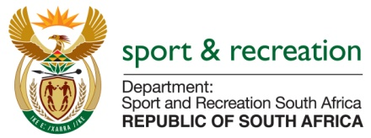

PARLIMENTARY QUESTION FOR THE MINISTER

QUESTION NO 3742

3742. Mr M S Malatsi (DA) to ask the Minister of Sport and Recreation:
With reference to his reply to question 2388 on 7 October 2015, has his department now sourced the information; if not, when will the information be made available; if so, what were the (a) salaries, (b) bonuses, (c) travel, airtime and data allowances and (d) stipends payable to the (i) Chief Executive Officer and (ii) Chairperson of the (aa) 2010 Fifa World Cup Bid Committee and (bb) 2010 Local Organising Committee in the (aaa) 2004-05, (bbb) 2005-06, (ccc) 2006-07, (ddd) 2007-08, (eee) 2008-09, (fff) 2009-10 and (ggg) 2010-11 financial years? NW4426E

REPLY

We are still trying to source this information as the Bid Company has long winded up its affairs and the information required is not readily available.

