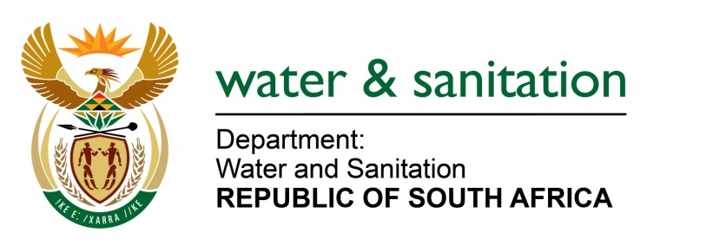

NATIONAL ASSEMBLY

FOR WRITTEN REPLY

QUESTION NO 3737

DATE OF PUBLICATION IN INTERNAL QUESTION PAPER: 16 OCTOBER 2015
(INTERNAL QUESTION PAPER NO. 40)

3737. Mr C D Matsepe (DA) to ask the Minister of Water and Sanitation:
With regard to the (a) 349 water projects and (b) 171 sanitation projects that are in various stages of pre-implementation and implementation in the prioritised 27 district municipalities, (i) in which municipality is each project situated, (ii) what is the (aa) nature, (bb) total budget and (cc) status of implementation of each project, (iii) who is the implementing agent of each project and (iv) when will each project be completed? NW4421E
---00O00---

REPLY:

(a) Currently, my Department is implementing 329 Water Supply Projects through the Municipal Water Infrastructure Grant within the 27 prioritized district municipalities as well as 33 Regional Bulk Schemes. The 33 Bulk Schemes consist of 30 Bulk Water Supply and 3 Bulk Waste Water Schemes. Refer to Annexure A.

(b) The following projects are located in Priority District Municipalities (colour coded in yellow) and a total of 230 Sanitation Projects. Refer to Annexure B.

The Bucket Eradication (BEP) programme is aimed at eradicating the legacy of bucket toilets in use as a form of sanitation in formal areas. This programme in the main seeks to deliver water borne sanitation to peri urban and urban settlements neglected with the provision of sanitation. The programme will include the construction of water and sewer reticulation (which ever is applicable or appropriate) complimented with new Toilet structures (replacing the bucket toilet) with connections to the bulk water and sewer (Waste Water Treatment Works). Alternatively, where water availability is a challenge and bulk infrastructure (Waste Water Treatment Works) not available and or the settlement patterns (low and dispersed settlements) as well as topography does not allow, alternative sanitation solutions will be provided i.e Dry, on site sanitation.

The Rural Household Infrastructure Grant (RHIG) programme seeks to provide basic level of service to households in amongst other the 27 Priority District Municipalities in South Africa (see table). The RHIG Grant allocation takes place in two fold i.e Direct and Indirect Grant. The Division of Revenue Act defines a Schedule 5b grant (which are grants allocated to municipalities for a specific purpose) are direct transfers to District Municipalities whereas Schedule 6B (Allocations-in-kind to municipalities for designated special programmes) grants to Local municipalities. In the main, the solution provided is a dry, on-site sanitation or a Ventilated Improved Pit Latrine (VIP) toilet addressing issues of water scarcity, bulk infrastructure availability, often dispersed settlement patterns and unfavourable topography.

Both Sanitation Projects are funded through a National Treasury Grant and for the 2015/16 financial Year, a total of R975 399 000,00 million is allocated towards the Bucket Eradication Programme and R115 510 million for the Rural Household Infrastructure Grant (RHIG) of which R48 182m is for direct grant (Schedlue 5B) and R67 328m is an Indirect Grant (Schedule 6B).

-2-

With regards to Bucket Eradication Programme, the Implementing Agents in 2014/15 financial year was Public Entities affiliated to the Troika Departments and are as follows:

PROVINCE | IMPLEMENTING AGENT
Eastern Cape | Nurcha
Free State | Bloemwater
Limpopo | Lepelle Northern Water
North West | Magalies Water
Northern Cape | Municipal Infrastructure Support Agent (MISA)  Sedibeng Water

However, following a recommendation from the Select Committee on Appropriations, the Department will phase out the use of Public Entities and accordingly, appointed Turnkey Contractors in the provinces where bucket toilets are still prevalent and include North West, Northern Cape, Free State and Eastern Cape.

With regards to the Rural Household Infrastructure Grant (RHIG) my Department will transfer the Direct Grant (allocation) to all Water Services Authorities (WSA’s) for implementation whereas the Indirect Grant (allocation) will see the appointment of suitable contractors by my Department for implementation. Refer to Annexure C.

---00O00---

