FOR WRITTEN REPLY QUESTION 373

NATIONAL ASSEMBLY
36/11411(201900036)

DATE OF PUBLlCAnoN iN INTER AL ‹zuEsTiON PAPER: 22 FEBRUARY 2019
(INTERNAL QUESTION PAPER NO 3-2019)

3Y3. Ms D Kohler (DA) to ask the Minister of Police:

Whether, with reference to the handling by the police of the murder case of a certain person (name furnished), who was killed in Burman Bush on 31 August 2018, there is an investigation underway into the manner in which the police handled the ma4er; if not, (a) why not, (b) why was the dog unit unable to assist in the search and (c) why were the police not adequately equipped with torches; if so, what are the relevant details?
NW397E
REPLY:

The murder case, Mayville, CAS 1/09/2018, is still under inVestigation. No arrests have been made. The post mortem and toxicology reports are outstanding.

Yes, there is an investigation underway into the manner in which the South African Police Service (SAPS) handled the matter. The complainant was interviewed and a member of the SAF'S has been appointed to deal with the complaint.

- Not applicable.

- On 31 August 2018, the Dog Unit was called to a scene of an armed robbery at Burman Bush and they responded within 10 minutes. Patrol dogs were used to search the area and the search continued until 04:00, on 1 September 2018, with negative results. At first light, on 1 September 2018, the search continued. A passer-by located the body of the deceased and informed the police.

- The Dag Unit, who conducted the search, had adequate equipment to conduct the search. The members from the police station did not have torches with them, at the time. When the detectives were called, on 1 September 2018, at apprDximately 09:00, there was no need for torches.

2

Original signed MAJOR GENERAL I/DIVISIONAL COMMISSIONER: DETECTIVE SERVICE L MAGSON

Date: 1 March 2019

Reply to question 373 recommended

Original signed LIEUTENANT GENERAL ACTING DEPUTY NATIONAL COMgIfSSIONER: CRIME DETECTION TC MOSIKILI

Date: 1 March 2019

Reply to question 373 recommended/

COM
LE (SOEG)
Date: tz13 -z3- 15

GENERAL ER: HAFRCANPOLCESERWCE

Reply to question 373 approved/npt-agpr
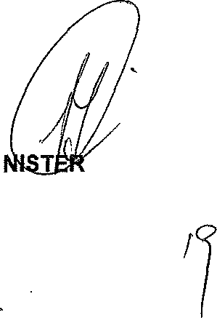
MI BH C
OF POLICE P
Date

NATIONAL ASSEMBLY

AUESTlONSFORWRtTTENREPLY

Internal Ref Number: Submission Date: Question Asked 8y: Question Asked To:
0175 - 2019

]9.02.2019
Ms D Xohler
Minister of Poltce

Question:
1. Whether, with reference to the handling by the police of the murder case of a certain person (name furnished [Mr Simon Millikin]), who was killed in 8urman Bush on 31 August 2018, there is an investigation underway into the manner in which the police handled the matter; if not, (a) why not, (b) why was the dog unit unable to assist in the search and (c) wHy were the police not adequately equipped with torches; if so, what are the relevant details?

NW I 8-36O6E

Researcher: Ruan van der Walt (3161 or ruanvdw@da.orp.za)

