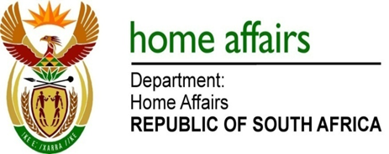

NATIONAL ASSEMBLY

QUESTION FOR WRITTEN REPLY

QUESTION NO. 3726

DATE OF PUBLICATION: Friday, 16 October 2015

INTERNAL QUESTION PAPER 40 OF 2015

3726. Mr J Vos (DA) to ask the Minister of Home Affairs:

Has his department implemented a special dispensation for minors from the Kingdom of Lesotho whereby they do not need to produce an unabridged birth certificate on entrance to the Republic of South Africa as long as they have a letter from a learning institution stating that they are in possession of the original unabridged birth certificate; if so, (a) on what date did the specified dispensation come into effect, (b) which (i) piece of legislation and/or (ii) regulation empowers his department to institute the specified dispensation, (c) on (i) what date and (ii) under what Government Gazette notice was the specified dispensation published and (d) what is his department’s definition of learning institution?
NW4410E
REPLY:

No, therefore (a-c) falls away.

(d) The Immigration Regulations, 2014 defines a "learning institution" as-

(a) an institution of higher education established in terms of the Higher Education Act, 1997 (Act No. 101 of 1997); or
(b) a college established in terms of the Further Education and Training Colleges Act, 2006 (Act No. 16 of 2006), but does not include-

(i) a school offering further education and training programmes under the South African Schools Act, 1996 (Act No. 84 of 1996); or

(ii) a college under the authority of a government department other than the Department of Higher Education and Training; or

(c) a school contemplated in section 1 of the South African Schools Act, 1996 (Act No. 84 of 1996);

