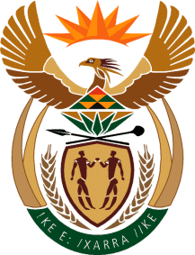

MINISTRY OF TOURISM

REPUBLIC OF SOUTH AFRICA

Private Bag X424, Pretoria, 0001, South Africa. Tel. (+27 12) 444 6780, Fax (+27 12) 444 7027

Private Bag X9154, Cape Town, 8000, South Africa. Tel. (+27 21) 469 5800, Fax: (+27 21) 465 3216

Ref: TM 2/1/1/10

NATIONAL ASSEMBLY:

QUESTION FOR WRITTEN REPLY:
Question Number: 3721
Date of Publication: 16 October 2015
NA IQP Number: 40
Date of Reply: 03 November 2015

Mr J Vos (DA) to ask the Minister of Tourism:
Whether a certain person (name furnished) is a consultant to his department; if not, in what capacity does the specified person work for his department; if so (a) what are the set key performance areas and outcomes of the specified person and (b) how is the specified person remunerated?
NW4405E
REPLY:

The person referred to is not a consultant, but is employed as a Special Advisor to the Minister.
- The person referred to is appointed as a Special Advisor in accordance with Public Service Act Section 12A (i), to:
  - Advise the Executive Authority on the exercise/performance of the Executive Authority’s powers and duties
  - Advise the Executive Authority on the development of policy that will promote the department’s objectives and
  - Perform such tasks as appropriate in respect of the exercise/performance of the Executive Authority’s powers and duties

- The person referred to is remunerated in accordance with Section 12A of the Public Service Act, 1994 and the relevant dispensation for Special Advisors, as contained in Section 17 of the Act.

