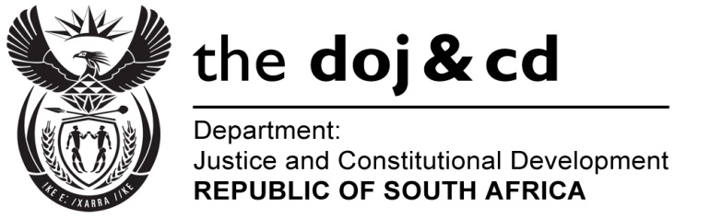

NATIONAL ASSEMBLY
QUESTION FOR WRITTEN REPLY
PARLIAMENTARY QUESTION NO: 372
DATE OF QUESTION: 19 FEBRUARY 2016
DATE OF SUBMISSION: 4 MARCH 2016

372. Ms J Edwards (DA) to ask the Minister of Justice and Correctional Services:
With reference to President Jacob G Zuma’s undertaking in his State of the Nation Address delivered on 12 February 2015, that the Government will set aside 30% of appropriate categories of state procurement for purchasing from Small, Medium and Micro-Sized Enterprises (SMMEs), co-operatives, as well as township and rural enterprises, what percentage of the total procurement of (a) his department and (b) every entity reporting to him went to (i) SMMEs and (ii) co-operatives from 1 April 2015 up to the latest specified date for which information is available? NW384E
REPLY
- (i) and (ii) The Department of Justice and Constitutional Development (DoJ&CD) including the National Prosecuting Authority (NPA), procures within the current framework in terms of the Preferential Procurement Regulations (PPR). The PPR was developed to support BBBEE and government specific goals.

94% of the departmental procurement supports government initiatives of which approximately 31% (R139 million) relates to SMMEs.

The department is awaiting the approval of the revised PPR that will provide for full implementation of the commitments made in the recent State of the Nation Addresses’ delivered.

The Office of the Chief Justice is submitting information in terms of the Broad Based Black Economic Empowerment scoring points system as prescribed by the Preferential Procurement Policy Framework Act, 5 of 2000. Information is submitted as follows:

Total amount spent on procurement from 1 April 2015 to 22 February 2016 by the Office of the Chief Justice amounts to R38 647 064.18. Of this amount R29 173 393.99 was spent on Black Economic Empowerment procurement (all Black Economic Empowerment levels). Therefore the Office of the Chief Justice spent 75.49% on Black Economic Empowerment procurement.

(b)(i) The Special Investigating Unit has indicated that the percentage of total procurement spend on SMME is sixty (60%) percent.

(ii) The SIU further indicated that no procurement was made from or in support of co-operatives and rural enterprises.

- (i) Legal Aid South Africa issued instructions to 11,831 judicare practitioners from 1 April 2015 to 31st January 2016 to the value of R96 million. These are all small law firms.

A total amount of R1.35 million, covering 1 April 2015 to 31st December 2015, was paid to five (5) law firms that are all based in rural areas and have Agency Agreements with Legal Aid SA.

An amount of R95,7 million constituting other procurements of services and goods by different suppliers were paid out for the period 01 April 2015 to 31st January 2016. Legal Aid SA awaits National Treasury’s comprehensive review of the existing Supply Chain Management legislative framework in respect of various specific goals, i.e., Small, Medium and Micro-sized Enterprises (SMMEs), co-operatives, as well as township and rural enterprises to classify procurements services going forward.

- (i) The Department of Correctional Services has not set aside 30% of its
procurement for purchasing from SMMEs, co-operatives as well as
township and rural enterprises as this is not yet supported by procurement
legal framework.

Currently contracts are awarded in accordance with the Preferential Procurement Policy Framework Act, 2000 and its Regulations, 2011 to the bidder scoring the highest points.

The information regarding the contracts awarded with values above R30 000.00 from 1 April 2015 to 19 February 2016 is as follows:

BEE Level | Total Contracts | Total Current Contract Value | Percentage
Level 1 | 470 | R 144 136 872.30 | 17.67%
Level 2 | 110 | R 426 205 448.05 | 52.21%
Level 3 | 496 | R 109 626 423.40 | 13.43%
Level 4 | 149 | R 94 095 598.66 | 11.53%
Level 5 | 17 | R 3 065 779.70 | 0.37%
Level 6 | 16 | R 4 504 798.52 | 0.55%
Level 7 | 3 | R 265 269.30 | 0.03%
Level 8 | 2 | R 381 480.00 | 0.04%
Non-compliant contributor | 203 | R 34 042 967.57 | 4.17%
Total | 1466 | R 816 324 637.50

National Treasury’s Summary Report: Contract(s) Awarded does not make provision for distinguishing of contracts awarded to Small, Medium and Micro-sized Enterprises, co-operatives as well as township and rural enterprises.

(ii) As above

- Not applicable

