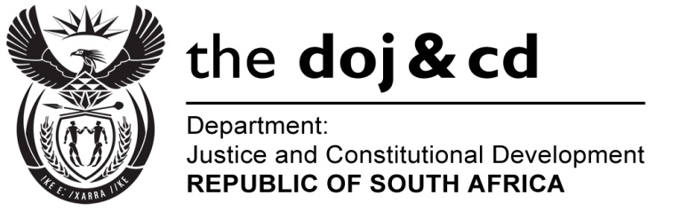

NATIONAL ASSEMBLY
QUESTION FOR WRITTEN REPLY
PARLIAMENTARY QUESTION NO: 372
DATE OF QUESTION: 19 FEBRUARY 2016
DATE OF SUBMISSION: 4 MARCH 2016

372. Ms J Edwards (DA) to ask the Minister of Justice and Correctional Services:
With reference to President Jacob G Zuma’s undertaking in his State of the Nation Address delivered on 12 February 2015, that the Government will set aside 30% of appropriate categories of state procurement for purchasing from Small, Medium and Micro-Sized Enterprises (SMMEs), co-operatives, as well as township and rural enterprises, what percentage of the total procurement of (a) his department and (b) every entity reporting to him went to (i) SMMEs and (ii) co-operatives from 1 April 2015 up to the latest specified date for which information is available? NW384E
REPLY
- (i) and (ii) The Department of Justice and Constitutional Development has indicated that the Department is submitting information in terms of the Broad Based Black Economic Empowerment (BBBEE) balanced scorecard as prescribed by the Preferential Procurement Policy Framework Act, 5 of 2000. For the period 1 April 2015 to 31 January 2016, 86.78% of the Departmental procurement spending was directed to contributor level 1-3.

B-BBEE Level of Contributor | No. of contracts | Total value | Percentage (%)
1 | 327 | 40 008 403.52 | 12.69%
2 | 215 | 178 607 300.06 | 56.67%
3 | 388 | 54 912 409.49 | 17.42%

Furthermore, Government officials can only act within the prescribed regulatory framework and the Department therefore awaits National Treasury comprehensive review of the existing Supply Chain Management legislative framework in respect of various specific goals, i.e., Small, Medium and Micro-sized Enterprises (SMMEs), co-operatives, as well as township and rural enterprises.

The National Prosecuting Authority has indicated that the total spent on contracts with Small Medium and Micro-Enterprises, is R77,5 million out of R94,1 million total spend, i.e., 82.35%.

(b)(i) The Special Investigating Unit has indicated that the percentage of total procurement spend on SMME is sixty (60%) percent.

(ii) The SIU further indicated that no procurement was made from or in support of co-operatives and rural enterprises.

