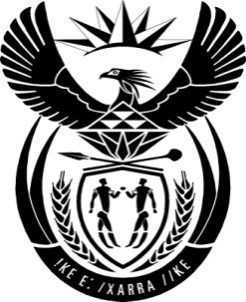

THE PRESIDENCY: REPUBLIC OF SOUTH AFRICA
Private Bag X1000, Pretoria, 0001
NATIONAL ASSEMBLY
QUESTIONS FOR WRITTEN REPLY

QUESTION NO : 3717
DATED : 16 OCTOBER 2015

The Leader of the Opposition (DA) to ask the President of the Republic:

Whether, given (a) the reply of the Minister of International Relations and Cooperation to question 3509 on 22 September 2015 and (b) his statements on 15 September 2015 during his foreign policy briefing confirming the invitation of a Sudanese delegation to the Forum on China-Africa Cooperation (FOCAC), President Omar al-Bashir of Sudan has been (i) invited to and/or (ii) confirmed his attendance at the FOCC Summit to be held in Johannesburg in December 2015?

DRAFT REPLY:
The President of the Republic of Sudan did not attend the Forum of China-Africa Cooperation Summit, (FOCAC).

