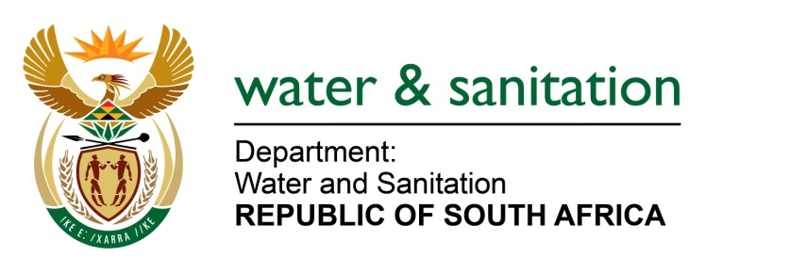

NATIONAL ASSEMBLY

FOR WRITTEN REPLY

QUESTION NO 3716

DATE OF PUBLICATION IN INTERNAL QUESTION PAPER: 16 OCTOBER 2015
(INTERNAL QUESTION PAPER NO. 40)

3716. Mr L J Basson (DA) to ask the Minister of Water and Sanitation:
Whether, with reference to her reply to oral question 315 on 19 August 2015, she communicated the date for the release of the Blue and Green Drop reports by 30 September 2015; if not, (a) why not and (b) when will she release the specified reports; if so, (i) when and (ii) what is the release date? NW4400E
---00O00---
REPLY:

My response to oral question 315 on 19 August 2015 indicated that I will possibly communicate the date for release by the end of September 2015, however, I have not yet communicated the date for the release of the Blue and Green Drop reports, as it is still due to be submitted to Cabinet for approval in line with the exercise of executive authority in terms of section 85 of the Constitution.

---00O00---

