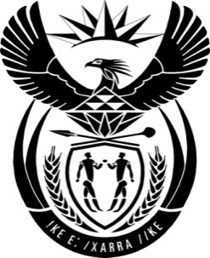

THE PRESIDENCY: REPUBLIC OF SOUTH AFRICA
Private Bag X1000, Pretoria, 0001
NATIONAL ASSEMBLY
QUESTIONS FOR WRITTEN REPLY

QUESTION NO: 3715

Date Published: 14 August 2015

The Leader of the Opposition (DA) to ask the President of the Republic:

- How many trip(s) has he taken to (i) Brazil, (ii) the Russian Federation, (iii) India and (iv) the People’s Republic of China since 1 April 2015, (b) on what date was each specified trip undertaken, (c) what was the purpose of each specified trip(s) and (d) which government (i) officials and/or (ii) presidential staff accompanied him on each specified trip(s)? NW4399E

Reply:

Since 1 April 2015 I have undertaken one Working Visit to China from 2-4 September 2015, to attend the 70th Anniversary of the Victory of the Chinese Peoples’ War of Resistance against the World Anti-Fascist War.
I was accompanied by the Minister of International Relations and the Deputy Minister of Energy.
The staff included senior managers as well as personal support staff such as researchers, protocol officers, media officers and security personnel.

