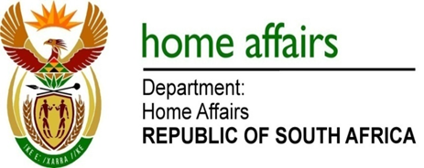

NATIONAL ASSEMBLY

QUESTION FOR WRITTEN REPLY

QUESTION NO. 3707

DATE OF PUBLICATION: FRIDAY, 10 NOVEMBER 2017

INTERNAL QUESTION PAPER 42 OF 2017

3707. Mr M Waters (DA) to ask the Minister of Home Affairs:

Does the Independent Electoral Commission intend to purchase new (a) software for running elections before the 2019 general election; if so, (a) what is the software called (b) from which company will the software be bought, (c) what is the cost of the software and (d) what is the purpose of the software? NW4138E

REPLY:

- The Electoral Commission has no intension to purchase new software for running elections before the 2019 general elections.

(b-d) Not applicable

