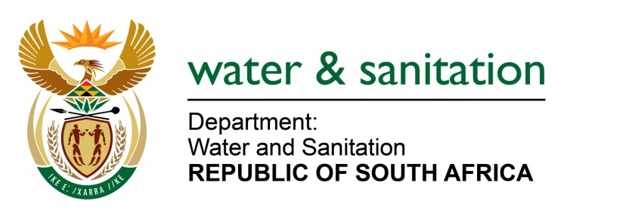

NATIONAL ASSEMBLY

FOR WRITTEN REPLY

QUESTION NO 3703

DATE OF PUBLICATION IN INTERNAL QUESTION PAPER: 14 OCTOBER 2022
(INTERNAL QUESTION PAPER NO. 38)

3703. Mrs M R Mohlala (EFF) to ask the Minister of Water and Sanitation:

(1) What are the reasons that the north and southwest areas of Johannesburg are experiencing inconsistent water supply;

(2) whether the Government still has water agreements with Lesotho; if not, what is the position in this regard; if so, (a) what are the reasons that the City of Johannesburg is experiencing shortage of water supply and (b) what measures of intervention have been taken to rectify the anomaly?

NW4535E
---00O00---

MINISTER OF WATER AND SANITATION

- According to City of Johannesburg (COJ), two of Rand Water’s purification plants, namely, Zuikerbosh and Vereeniging as well as two major pumps stations (Palmiet and Eikenhof) supplying large parts of the city were affected by power failures. The municipality’s entity, Joburg Water, reported that Eikenhof system was not being operated to full capacity to boost the Palmiet system which was at a critical level. This has resulted in portions of the Eikenhof system, which supplies Crosby, Brixton, Hurst Hill, Crown Gardens and Eagles Nest systems to collapse completely on 4 October 2022.
During engagements with Rand Water, it was agreed that the Eikenhof system should be operated at full capacity and to no longer sustain the Palmiet system. This resulted in flows to Crosby, Brixton and Hurst Hill reservoirs being improved.

- Yes, the Treaty between South Africa and Lesotho remains in force. The project generates hydroelectricity for the benefit of Lesotho citizens, while water is transferred to meet the water needs of South Africans. This water meets 60% of Gauteng’s water demand.

- Rand Water’s operating philosophy is to maintain the reservoir levels between 60- 80%. This targeted range is intended to enable the network system to be resilient and respond to any challenges. Historically, during September to January, water consumption increases exponentially in Gauteng. It was with this understanding that wrote to the high consumers; City of Tshwane, City of Johannesburg, and City of Ekurhuleni; to encourage and plead for reduced consumption in anticipation of the increased demand for water. Despite these efforts, water consumption continued to increase significantly.
Rand Water’s overall water storage declined from 52% to 38%. Stemming from this decline, a meeting was convened with the Metros to notify them of the intention to apply Stage 1 restrictions. Despite these efforts, water storage levels continued to decline and that prompted Rand Water to apply Stage 2 restrictions. The anticipated heatwave informed the decision to escalate from Stage 1 to 2 (. The restrictions are necessary to stabilize the system and avoid total collapse of the systems.
- It must be noted that Rand Water’s water treatment plants and booster sites are exempt from loadshedding. However, there are two (2) tertiary booster sites in the network that are subjected to loadshedding where diesel generators are used to manage the impact of loadshedding.

The approach for implementing restrictions involves communication on implementation of restrictions to all municipalities that are supplied by Rand Water and to implement restrictions to the three Metros which utilise approximately 80% of Rand Water’s supply, as well as:
  - Identifying major meters under each municipality that will be restricted (53 meters under Johannesburg, 57 under Ekurhuleni and 28 under Tshwane).
  - These meters are monitored over a period of two weeks to assess and review progress to achieve the desired results. As for the current stages two (30%) water supply restrictions that has been implemented effective from 04 October 2022, will be reviewed
  - If the performance of Rand Water’s supply has not improved after two weeks, the review of the implemented water supply restrictions will dictate if other municipalities will be included
- If the performance of Rand Water’s supply does improve after two weeks, the review of the implemented water supply restrictions will dictate reduction to stage one (10%) or removal of restrictions.
These restrictions are aimed at restoring the overall reservoir storage capacity to approximately 60%. Rand Water has formally consulted with the affected municipalities to inform them of its intention to implement the restrictions. The situation is reviewed on an hourly basis and where improvements are made, Rand Water lifts the restrictions to provide reprieve. Rand Water’s consultation with the customers is designed to ensure that no areas are left without water for a prolonged period.

---00O00---

