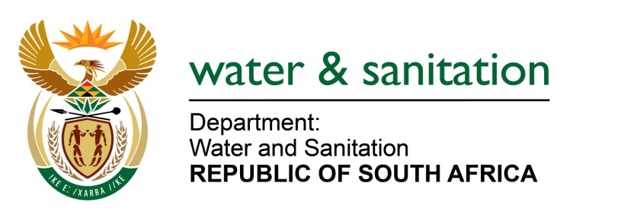

NATIONAL ASSEMBLY

FOR WRITTEN REPLY

QUESTION NO 3702

DATE OF PUBLICATION IN INTERNAL QUESTION PAPER: 14 OCTOBER 2022
(INTERNAL QUESTION PAPER NO. 38)

3702. Mrs M R Mohlala (EFF) to ask the Minister of Water and Sanitation:
(a) How was the budget for the R3 billion bulk water project in Giyani spent and (b) what total number of (i) officials and (ii) politicians have been arrested for corruption relating to the specified project?
NW4534E
---00O00---

MINISTER OF WATER AND SANITATION

- The budget for the R3 billion bulk water project in Giyani was spent as indicated in the table below.
PROJECT NAME | LTE | SOUTH ZAMBEZI | KHATO CIVILS | TOTAL SPEND
Giyani Intervention | 181,534,525.82 | 171,737,633.33 | 2,544,327,974.52 | 2,897,600,133.67
Nandoni | 52,195,702.16 | 22,779,243.65 | 0 | 74,974,945.81
Nwamitwa | 104,559,644.15 | 60,678,623.86 | 0 | 165,238,268.01
Makoxa | 2,446,636.00 | 0.00 | 0 | 2,446,636.00
Total | 338,289,872.13 | 255,195,500.84 | 2,544,327,974.52 | 3,140,259,983.49

- The Special Investigation Unit (SIU) made a referral to the National Prosecution Authority (NPA) and the Directorate for Priority Crime Investigation (the HAWKS) on 3 April 2018 for criminal charges against the former Chief Executive Officer of Lepelle Northern Water for contravening the provisions of the Public Finance Act (PFMA). Another referral was made to the NPA for charges against the manager responsible for Planning GIS on 20 September 2018 for collusion, and fraud. The investigation is in progress and no arrests have been made so far.

- No referral was made to the NPA for charges against any politician.

---00O00---

