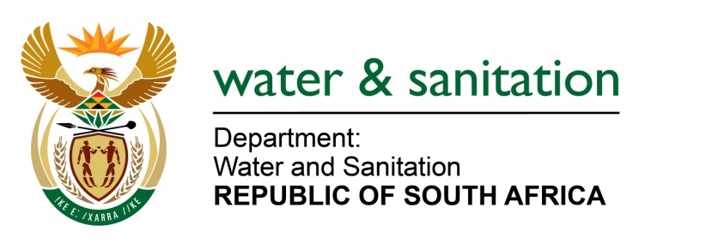

NATIONAL ASSEMBLY

FOR WRITTEN REPLY

QUESTION NO 3701

DATE OF PUBLICATION IN INTERNAL QUESTION PAPER: 14 OCTOBER 2022
(INTERNAL QUESTION PAPER NO. 38)

3701. Mrs M R Mohlala (EFF) to ask the Minister of Water and Sanitation:
(a) What measures of intervention have been put in place to prevent the projected water deficit by the year 2040, (b) to what extent will the plan benefit rural communities in small rural municipalities and (c) what are the timelines for implementing the specified intervention measures?
NW4533E
---00O00---

MINISTER OF WATER AND SANITATION

- The Department undertakes planning studies over different planning horizons to derive interventions that are implemented to ensure water security for the entire country. These interventions incorporate enablers like governance, financing, human capacity building and science and innovation that facilitate implementation of water projects at National, Provincial and District and Local Municipality level.

The interventions implemented for our water security are contained in the National Water Resource Strategy (NWRS), the instrument by which the minister gives effect to the National Water Act, as well as the master plans that emanate from the NWRS. The various studies informing the NWRS are available on the DWS website, at http://www6.dwa.gov.za/iwrp/projects.aspx, and the National Water and Sanitation Master Plan (NW&SMP) is available at http://www.dwa.gov.za.

Some of the work done by the department in relation to long term planning includes the development of the:
- Water Reconciliation Strategies
- Five-year Water and Sanitation Reliability Plans for all District Municipalities in South Africa.

The key outputs of the scenario planning are strategies to reconcile water requirements and availability for all large integrated systems in the country as well for localised water resource systems that secure water for small towns, villages, or clusters of settlements. Reconciliation strategies inform water security perspectives into national, provincial, and local planning instruments such as the National Development Plan, NWRS, Provincial Growth and Development Strategy, Water Service Development Plans and vice-versa

The objective of the Five-year Water and Sanitation Reliability Plans for all District Municipalities is to develop a Water and Sanitation Services Situational Assessment of the current service levels and infrastructure referenced to households at community level. The situational assessment information knowledge base is then interpreted into a needs perspective that categorises each supply need and gap analysis into a reliability category. Projects are then identified to address each of the reliability needs classification categories and a funding model developed that enables a five-year pipeline of projects implementation plan that integrates all grant funding. The full development of the plans for all 44 District Municipalities is scheduled to be completed by March 2024.

- The identified interventions cover the whole country and benefit all the municipalities and communities in the country.

- The plans extend cover continuous daily and weekly monitoring of water levels, to the Annual Operating Analyses which optimise annual water management, to at least 25-year planning horizons for the water resource reconciliation studies and beyond. The plans conducted as indicated in (a) above provide the direction of strategies for the country’s water security, which are continuously firmed up on a progressive basis to make them dynamic. The plans are continuously monitored and updated every 3 to 5 years to ensure that they remain current and relevant.
---00O00---

