###### National Assembly

Question Number: 3697

**Adv A de W Alberts (FF Plus) to ask the Minister of Transport**

1. How many road users have bought e-tags for the Gauteng Freeway Improvement Project (GFIP) e-tolling system in Gauteng in each month since 03 December 2013;
2. How many of the e-tags that have been bought since 03 December 2013 are (a) still active accounts and (b) no longer being used;
3. How many road users have been using the GFIP freeways where the e-tolling system has been installed in each month since 03 December 2013;
4. What is the monthly amount that has been levied by the e-tolling system since December 2014? NW4378E

**REPLY**

1. The number of road users who bought e-tags for the Gauteng Freeway Improvement Project (GFIP) e-tolling system in Gauteng in each month since 03 December 2013 are as follows:

|  |  |
| --- | --- |
| Date period | Tag assigned to account |
| 20131203 | 265 514 |
| 201401 | 168 175 |
| 201402 | 114 062 |
| 201403 | 89 689 |
| 201404 | 71 590 |
| 201405 | 63 963 |
| 201406 | 67 275 |
| 201407 | 52 854 |
| 201408 | 41 796 |
| 201409 | 35 696 |
| 201410 | 32 398 |
| 201411 | 26 329 |
| 201412 | 19 426 |
| 201501 | 25 628 |
| 201502 | 23 285 |
| 201503 | 22 673 |
| 201504 | 19 892 |
| 201505 | 23 810 |
| 201506 | 30 626 |
| 201507 | 37 852 |
| 201508 | 31 738 |
| 201509 | 32 190 |
| Total | 1 296 461 |

1. All e-tags bought since 03 December 2013 are (a) active as and when the road network is used.
2. See (a) above.

(3)  How many road users have been using the GFIP freeways where the e-tolling system has been installed in each month since 03 December 2013;

|  |  |
| --- | --- |
| Unique VLN's  (Unique vehicle plate numbers) | |
| Class | Overall |
| Dec-13 | 2,410,896 |
| Jan-14 | 2,364,201 |
| Feb-14 | 2,262,121 |
| Mar-14 | 2,356,039 |
| Apr-14 | 2,389,110 |
| May-14 | 2,389,987 |
| Jun-14 | 2,373,444 |
| Jul-14 | 2,423,919 |
| Aug-14 | 2,442,606 |
| Sep-14 | 2,437,115 |
| Oct-14 | 2,521,269 |
| Nov-14 | 2,539,513 |
| Dec-14 | 2,654,032 |
| Jan-15 | 2,544,343 |
| Feb-15 | 2,483,322 |
| Mar-15 | 2,599,570 |
| Apr-15 | 2,593,900 |
| May-15 | 2,571,134 |
| Jun-15 | 2,521,515 |
| Jul-15 | 2,607,359 |
| Aug-15 | 2,614,246 |
| Sep-15 | 2,585,302 |

(4) The monthly amount that has been levied by the e-tolling system since December 2014?

Please see the graph below

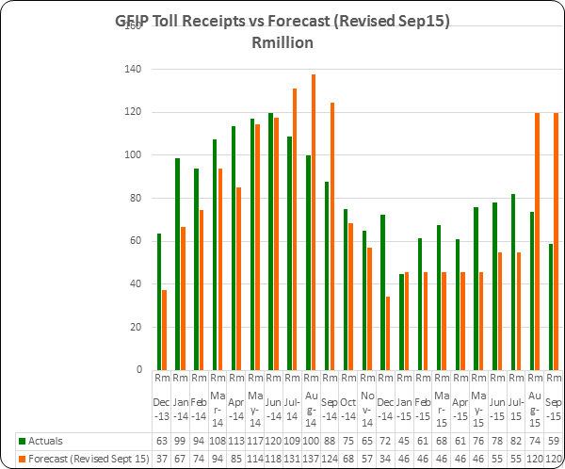

Please note that the cash flow projections for August and September 2015 took into account the 60% discount offering for historic debt that will now become available to the public from 2 November 2015.