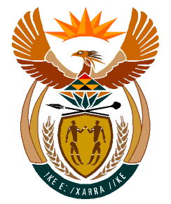

MINISTRY
HUMAN SETTLEMENTS
REPUBLIC OF SOUTH AFRICA

Private Bag X645, Pretoria, 0001. Tel: (012) 421 1309, Fax: (012) 341 8513

Private Bag X9029, Cape Town, 8000. Tel (021) 466 7603, Fax: (021) 466 3610

NATIONAL ASSEMBLY
QUESTION FOR WRITTEN
QUESTION NUMBER: PQ 3695
DATE OF PUBLICATION: 14 October 2022

Mr T Mogale (EFF) to ask the Minister of Human Settlements:
What total number of social housing schemes are currently(a) under her department,(b) being planned and/or (c) under construction? (NW 4524E)

REPLY:
- There is a total of 194 completed and tenanted social housing projects representing a portfolio of 42 797 units as at end March 2022
- The pipeline of new social housing projects planned and not yet approved include seventy-eight (78) projects with the potential for delivery of 46 646 social housing units.
- Fifty-three (53) social housing projects with 25 891 social housing units have been approved and are at different stages of construction.

