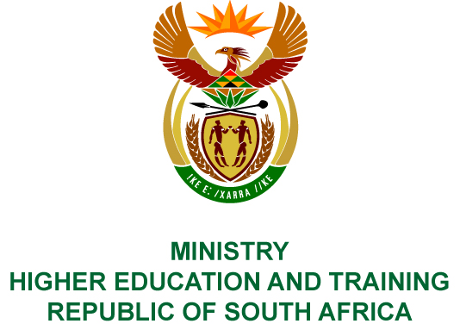
Private Bag X893, Pretoria, 0001, Tel (012) 312 5555, Fax (012) 323 5618
Private Bag X9192, Cape Town, 8000, Tel (021) 469 5150, Fax: (021) 465 7956
Memorandum from the Parliamentary Office
NATIONAL ASSEMBLY
FOR WRITTEN REPLY
QUESTION 3690
DATE OF PUBLICATION OF INTERNAL QUESTION PAPER: 30/11/2018
(INTERNAL QUESTION PAPER NO 44 OF 2018)
Ms Y N Yako (EFF) to ask the Minister of Higher Education and Training:
(1) (a) What is the total number of cases of corruption at technical and vocational education and training colleges in the country that have been reported to her department or which her department was made aware of by the SA Police Service in the 2017-18 financial year and (b) what are the details of the reported cases in each case;
(2) was each case investigated by her department; if so, (a) what was the outcome of each investigation and (b) what is the name of each person who was implicated?
NW4263E
REPLY:
- (a) The were no reported cases of corruption received by the Department from Technical and Vocational Education and Training colleges or the South African Police Service in the 2017/18 financial year.
(b) Not applicable.
- (a) Not applicable.
(b) Not applicable.

